Verex-ID™ User Guide



IDSCience
508-321-1671
23 Jayar Rd.,
Medway, MA. 02053 www.advancedIDdetection.com

Copyright © 2010-2016, Advanced ID Detection LLC, All Rights Reserved
Rev 20180515

Contents
Contents 2
Getting Started 4
Software Installation 4
Verex-ID 5
Starting Verex-ID 5
The Verex-ID Screen 7
Title Bar 7
Status Bar 8
Verex-ID Screens 8
Summary Tab 9
Forms Tab 18
Tests Tab 19
Micro/Pat Tab 20
CrossCheck Tab 21
Camera Tab 22
Help Tab 23
Review Tab 25
Privacy 27
Basic Tab 27
Options Tab 28
Options / Screen Tab 30
Options / General Tab 31
Options / Camera Tab 32
Options / Logging Tab 33
Options / Forms Tab 34
Options / Watchlist Tab 35
Options / Passback Tab 36
Options / HW Tab 37
Documentation 38
The IDS-1000 Reader 40
Power 41
USB Connection 42
Power Switch 43
Indicator Lights 43
Placement of the Reader 43
Front Graphics 44
Top Cover 45
Lower Reader 47
Lower Optical insertion Sensors 47
Magnetic Head 47
Lower Contact Image Sensor (CIS) 47
Front and Rear Rollers 47
Left Side Fence 47
Upper Reader 48
Upper Contact Image Sensor (CIS) - White 48
Upper Contact Image Sensor (CIS) – Near-Infrared (NIR) 48
Rollers 48
Lower Optical insertion Sensors 48
Troubleshooting Guide 49
Stopping and Starting the Verex-ID Service 52

Welcome

Verex-ID was designed to be an easy-to-use means of checking IDs – powerful, but simple enough to use with just a little training. This manual in PDF form is available for viewing via the Documentation button on the Help tab of the Verex-ID application.
The Verex-ID™ System represents state-of-the-art software and machinery in ID checking and authentication systems. Other ID systems typically just read the magnetic stripe or 2D barcode information and calculate age from that, while our IDScience Software recognizes a counterfeit ID using higher features that go more in depth than a barcode or magnetic stripe reader. The IDS-1000 reader scans both sides of an ID in full 24 bit color at 600 dpi resolution and is capable of detecting microprint, holographic patterns, and other security features; such as specific location of a signature. It also collects a Near-Infrared (NIR) image which is sensitive to carbon based ink, whose presence or absence is a useful security feature. On top of that, it also will read a barcode and magnetic stripe.
The system by default can read and authenticate driver’s licenses and IDs from all US states, Canadian provinces, and Mexican states. In addition, it reads military cards, alien registration cards, passport cards, and many more. International coverage expands this to most of the world’s IDs, overall making more than 2800 document types accepted and covered by our software. The scanner is compact and reliable. A camera option captures and stores a facial image of the person for comparison with the ID photo. The whole ID process takes place in just a few seconds. Monthly updates to the system keep the system current, meaning it is up to date with the new IDs that are coming out, as well as new fake variations.
The Verex-ID interface provides a very easy to use display of the ID and its characteristics. It shows basic ID information such as name, date of birth, and moves into more elaborate information such as the biometric characteristics of the person, just to name a few. High resolution images of the front and back are shown, and the user can zoom in to check details. A barrage of security checks are performed on the ID (depending on the specific ID type identified). Problem areas are automatically indicated for further analysis. A log of all IDs scanned (including results, front, back, IR ID images, and live ID photos) can be kept in encrypted form and reviewed later. The system is extremely easy to use and requires minimal training, providing “peace of mind” to organizations whose employees are not generally familiar with all the ID variants that they may come across in the course of their duties.
IDScience is based in Medway, MA and its website can be found at https://www.idscience.io/.
Since its introduction in early 2018, the Verex-ID system from IDScience has become the age verification system of choice, particularly for liquor serving and selling establishments. Verex-ID Systems are currently deployed across the country in a wide variety of applications, including police departments, restaurants, liquor stores, bars, clubs, convenience stores, retail stores, and casinos.
The principals of IDSCience are the original inventors of this unique, patented technology and are capable of quickly modifying the product to custom requirements. There is no other product on the market with the array of ID capabilities and ease of use of the Verex-ID system.

Getting Started

Your Verex-ID System typically consists of the following physical components:

- IDS-1000 Scanner
- IDS-1000 Power Supply
- USB Cable
- Installation CD
- Quick Start Installation Guide
- Windows based PC (laptop or desktop)

The Verex-ID system runs on a Microsoft Windows equipped PC. This may be a laptop or a desktop and may be supplied by IDScience or by the user. It is recommended that the PC have at least a Dual Core Processor (Intel recommended), a minimum of 1 GB of memory, and at least a 40 GB hard drive. Verex-ID runs under Microsoft Windows XP, Vista, Win 7, Win 8 or Win8.1.
Generally, the PC will come preinstalled with the Verex-ID system and will be ready to run when turned on. The PC will be supplied with current Windows updates, will have the proper settings for running the Verex-ID system, and will boot up into the Verex-ID application.
NOTE: Optionally, some systems may include the IDS-9000 Passport Scanner, or IDS-5000 Card Scanner (and associated power supply) in place of, or in addition to, the IDS-1000 ID Scanner.

Software Installation

There are two components to the software installation – the Verex-ID™ recognition engine and the Verex-ID user interface.
The Verex-ID engine is a Windows service that runs in the background on the computer. It communicates with the scanner to get images, processes the images and communicates the results to the Verex-ID program which serves as the user interface. The Verex-ID engine only gets to work when a card is inserted into the reader— otherwise it just waits in the background. After it is installed, the Verex-ID engine’s presence and status is indicated by an icon in the lower right hand system tray. If Verex-ID is running, the icon will be displayed as normal. If the Verex-ID service is not running, the icon will have a red “X” indicated.
The Verex-ID™ application serves as the user interface. This powerful package will let you instantly evaluate any scanned ID at a glance. You can also delve deeper into the analysis of any particular ID with additional tabs in the application. Normally the Verex-ID application will be started up automatically upon booting the system. However, there should also be an icon for Verex-ID found on the Windows desktop.
In most cases, our systems are delivered with software pre-installed. However, you may have received an installation CD with your system. Alternatively, installation could be done from a memory stick or even a portable hard drive. Please see the separate Verex-ID installation Guide for instructions on software installation.

Verex-ID

Verex-ID ™ is a software application designed to assist you in evaluation of IDs. At a glance, it provides the information that you need to determine whether to accept or reject an ID upon its presentation to you. The main “Summary” screen of Verex-ID should allow you to answer these four critical questions:
- Is the ID real or fake?
- What is the age of the person?
- Is the ID expired?
- Is the person depicted on the ID the same as the person presenting it?
The information depicted on the primary screen is aimed at helping you through both words and images. Other tabs will enable you to “drill down” for further detailed analysis of an ID if necessary. The following sections will explain in detail the operation of each section of Verex-ID.

Starting Verex-ID

Normally the Verex-ID application will be automatically running when the computer is turned on or rebooted. The normal installation process for Verex-ID puts Verex-ID into the list of programs that are automatically started. You can tell if Verex-ID is running as indicated by the Indicator Message in the program Taskbar at the bottom of the Windows screen. If Verex-ID is running in “Popup” mode, just the Taskbar indicator will be showing. Otherwise, the program itself should be visible on the screen as well as having an indicator in the Taskbar.
If the Verex-ID application is not currently running, then you can easily start it by double-clicking the Verex-ID icon on the desktop. This icon is normally automatically created for you during the installation process. If it is not present, you can find the application executable itself in your computer’s “Program Files (x86)” directory typically in the “Verex-ID” sub directory. Use the Windows Explorer program to navigate to “c:\Program Files (x86)\Verex-ID”. The application will be listed as VerexID.exe.
If a shortcut does not yet exist, you can right-click drag the Verex-ID application onto the desktop and then select “Create Shortcut here.”

The Verex-ID Screen

The Verex-ID Screen consists of a Title Bar at the top, a Tab section, and a Status Line at the bottom.

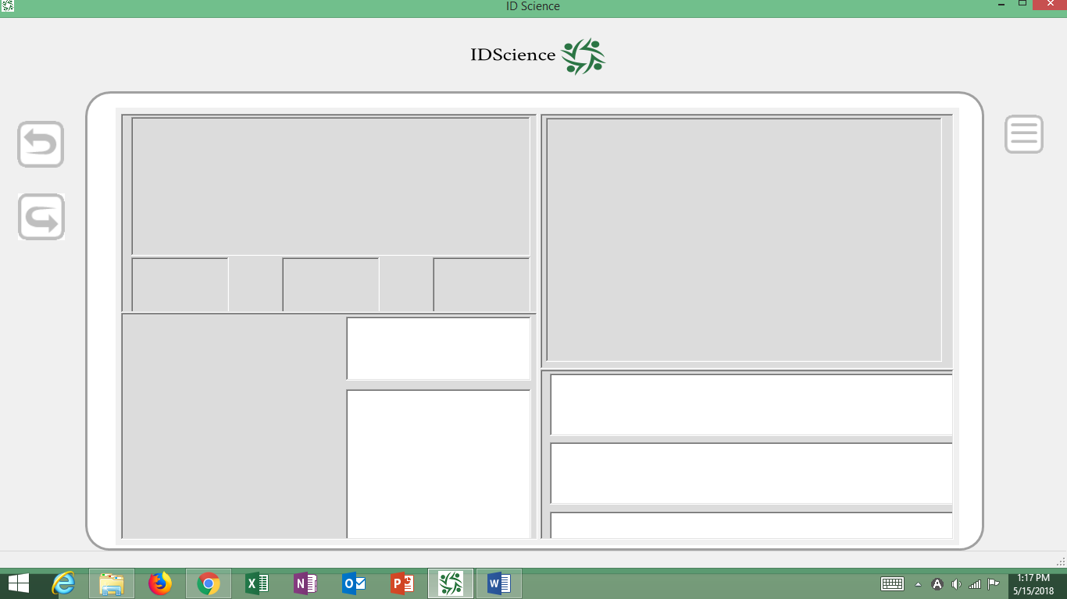

Title Bar

The title bar will read “IDScience”.
Clicking and holding the mouse on the Title Bar will enable you to move the application window around the screen (unless it is already in full screen “Maximized” mode).

On the right hand of the screen are the standard Window controls for “Minimize”, “Maximize”, and “Exit”, indicated by a bar, a square, and an “X”. Clicking the bar will minimize the window down to the
Taskbar. Clicking the square will scale the window up to “full screen” mode (on the active screen). Clicking the “X” will close the Verex-ID application. When the application is closed, it will reopen in the same position and size as when it was closed.


Status Bar

The line at the bottom of the Verex-ID window is the status bar. The message here serves as an indication of the state of processing for IDs.
Typically it will have the message “Ready”, which means that the ID engine is waiting for an ID to be inserted in the reader. The “Ready” indication means that the Verex-ID service is running.
Once an ID is inserted, the message will change to “Busy” and then blank indicating that the ID is being processed.
At some point during the processing, the message will change to “The ID may be removed from the reader.” Even though the final result has not been displayed, the Verex-ID system has scanned and collected all the information necessary from the ID. You may remove the ID and be prepared to return it to the presenter pending the final outcome of the process.
Finally, when the ID has been full processed, the message will again say “Ready” indicating that the system is ready for another ID to be scanned and processed. These various states will be accompanied by associated sounds (assuming that you have a working sound output device).

Verex-ID Screens

There are a set of standard “screens” used in the Verex-ID application. The screen titles and a brief description of their function are provided below.
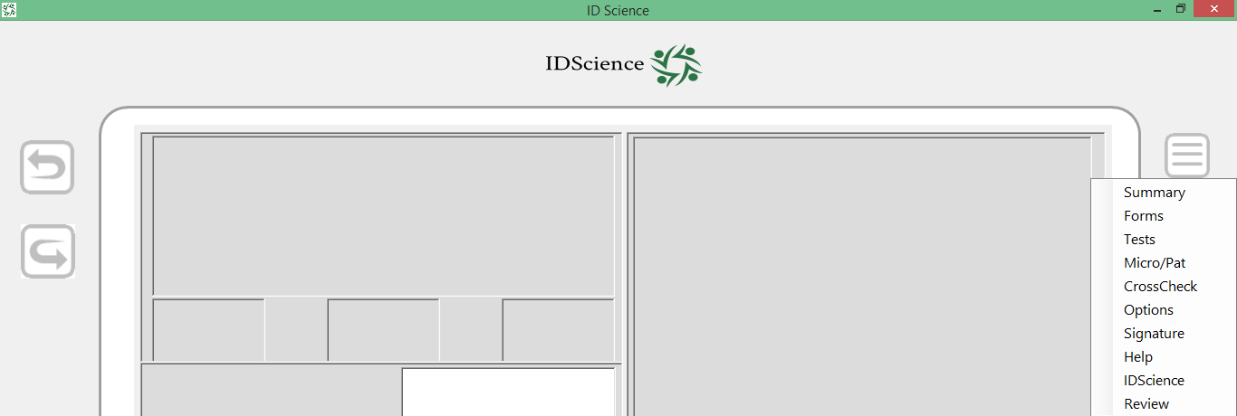

- Summary - main application summary screen
- Details - provides a more detailed look at the data extracted from an ID
- Tests - a list of the validation tests performed on an ID and the results
- Micro/Pat – Microprint/Pattern - a more detailed look at certain areas on the screen
- CrossCheck – compares information from different sources on an ID
- Camera – shows the images captured from an optional live camera
- Options – password protected user settable options
- Help – version and support information
- Review – password protected screen to allow review of previous scans
- IDScience – a privacy screen that can optionally cover the main data screen for privacy

Summary Tab

The Summary tab shows images of the front and back (for IDs) of the ID, NIR image of the front, and UV of the front (selected readers). In addition, the Summary tab breaks out images of the date of birth, the date of expiration, and the ID photo. Any images in the Verex-ID application can be blown up to full screen with a click and returned to the previous view with a click. Any region of any image can be viewed in detail with a magnifier window by simply moving the cursor over it. This ability to quickly examine minute details of the document (such as microprint features) provides an easy confirmation of any automatic results. The ID photo can be shown full screen (with biometric info and pertinent questions) for comparison with the ID presenter.

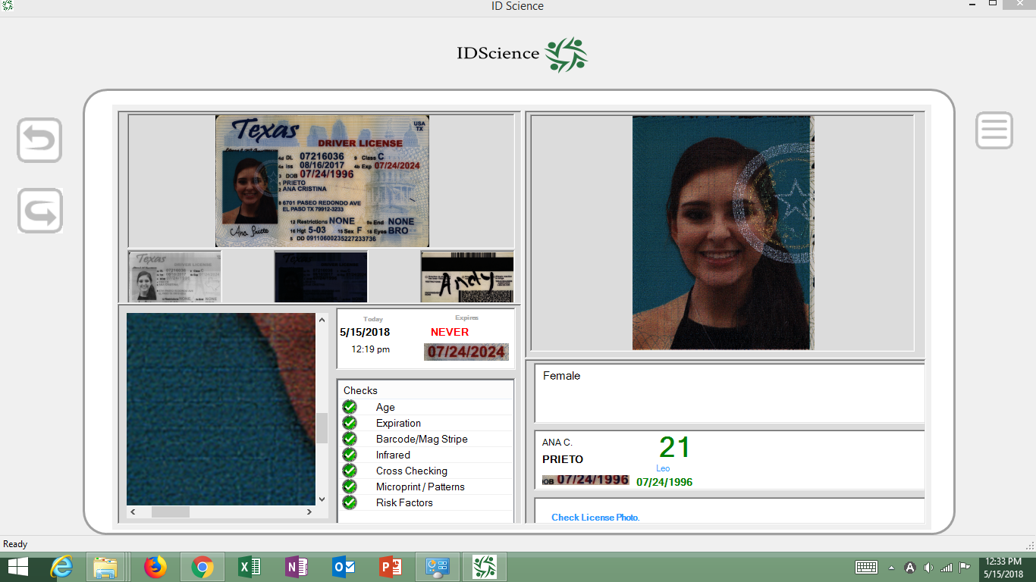
The summary displays the current date and time, current age, date of birth, and expiration date of the ID. Personal data displayed includes the name, photo, and biometrics such as height, weight, eye and hair color (if present on ID), as well as the astrological sign (to assist in detecting imposters). The ID is classified as to the Issuing Authority, the specific type of ID (e.g. Driver’s license), and a series identifier (usually the year of first issue).
Prominently featured on the Summary tab is an overall authentication result represented as either a green check mark (if good) or a red “X” (if there is a problem). In addition, there are displayed authentication “sub results” (with their own check or “X” indicator), which help to narrow down any problem areas on the ID – age (old enough), expiration, barcode/magstripe, infrared, cross-checking (consistency between OCR, barcode, and magstripe results), microprint /patterns (feature checks), or other risk factors.
On the Summary tab there are means to clear the results, minimize the application, click in or out of any image to a full screen view, switch to other tabs with details on the checks, or get a magnified view of the current cursor position over any of the images.

The “Summary” tab is the main application interface. For many users, this may be the only screen that they normally use. The “Summary” tab is divided into four sections. The left side of the screen is more oriented to the analysis of the ID, while the right side is focused more on the analysis of the person presenting the ID.

License Image Display
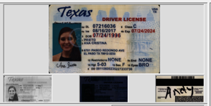

The upper quadrant displays a full color image of the front side of the ID itself with smaller images below. The left smaller image is a Near-Infrared image of the front of the document, rendered in grayscale. The right smaller image is a color image of the back of the license which usually contains a 2D barcode or magnetic bar code stripe. If there is a supported scanner (e.g. IDS-2000) that provides an Ultraviolet (UV) image, it will be displayed as a color image in the center.

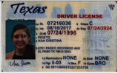
Visible Image

The images displayed have been scanned at a very high resolution, e.g. 600 dots per inch (DPI) for the IDS-1000 scanner, and much detail should be visible when shown in full screen mode. The larger upper image represents the front side of the ID.

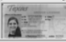
Near-Infrared (NIR) Image
Near- Infrared (NIR) is in a different low non-visible part of the spectrum from UV. Unlike UV, there is no light that can be shone onto an ID and make it visible – it can however be detected by either camera of scanner. Basically, the NIR image is sensitive to carbon-based ink – it will show black where carbon based ink has been used in the printing process. On some licenses, information will be visible in the NIR image, while in others, there may be special security patterns only visible in NIR light. The Verex-ID system performs some security checks on the NIR image, checking both for features that are supposed to be there for a particular style of ID or the alerting for details that are NOT supposed to be present.

Back (Visible)
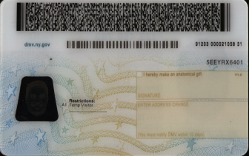
The back image is useful since it contains the magnetic stripe and usually the bar code information. Examining the quality of the 2D barcode is often a good clue as to whether the ID is genuine or not. A poorly printed barcode may not be able to be read. The backs of some IDs also contain security features such as microprint.
Ultraviolet (UV) – (certain scanner models only, e.g. IDS-2000)
You may be familiar already with the use of an Ultraviolet (UV) light to bring out hidden security patterns on IDs. Many IDs have such patterns and some scanner models can detect such patterns. Today many producers of fake IDs have learned to duplicate these UV patterns (even the ones that are multicolored). You can always utilize an auxiliary UV light to examine the presence of UV features where the UV light will excite the ink to glow in portions of the visible spectrum.

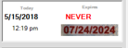
Expiration Panel Display
The expiration date of an ID is an important factor for many types of transactions. For instance, it is illegal in many jurisdictions to sell alcohol to a person with an expired ID. With all the varied formats of licenses from jurisdiction to jurisdiction, manually locating the expiration date on an unfamiliar ID can take precious seconds. Verex-ID can assist the ID process by automatically locating the expiration date (and others such as the birth date) automatically.
The panel below the display images is devoted to the analyzing the expiration of the license. The left side of the expiration panel show the current date and time of the scan under the label “Today”. The right side of the panel is labeled “Expires” and displays the expiration date of the license in both text and image form. The text information is displayed in the MM-DD-YYYY format.
Immediately below the expiration date text is a small cutout image from the main license image corresponding to expiration date. While this image is small, simply clicking on it will bring up a full screen image of that section of the main license. At this greatly magnified view, it is easier to see if the expiration date may have been manually modified.

Checks Summary Display
At the bottom left of the Summary tab is the Checks Summary display. This table shows at a glance what problems may exist with a given ID. In the process of analyzing an ID, many security checks are performed, all tailored to the characteristics of the particular license. The following checks are provided along with a brief description of what the checks indicate:
- Age – checks if the person is of legal age
- Expiration – checks if the ID is expired
- Barcode/MagStripe – checks for presence and consistency of barcode/magstripe information
- Infrared - security feature tests related to the Near Infrared (NIR) image
- Cross Checking – checks for consistency among the visible, barcode, and magstripe information
- Microprint/Patterns – checks for microprint and other pattern related security features
- Risk Factors – checks the entire ensemble of security feature tests
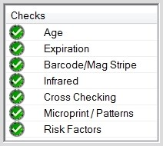
For each factor in the Checks table there is a corresponding icon which is either a green checkmark or a red “X” within a circle. These icons indicate potential problems with that particular factor in the ID evaluation process. For example, if the there was a red “X” next to the Expiration line, it would indicate that the ID is most likely expired.
Clicking on the checks will, in most cases, result in a more detailed look at the issue in question. For example, clicking on the Expiration line will provide a full screen view of the Expiration image cutout. Clicking on the Microprint/Patterns check will result in going to the “Microprint/Patterns” tab which will show further information.

Magnify Panel
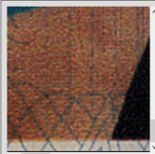
This lower left corner panel displays the magnified view of the current cursor position. The magnified view will appear whenever the cursor is over some portion of graphic image. The image could be any of the ID images, the photo image, expiration or date of birth image. It provides a quick way to examine the ID for security features such as microprint, textures, barcode quality, etc. The right and bottom edge sliders provide a relative indication of the position of the magnified cutout within the whole image on which the cursor is resting.

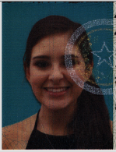
Photo Display Quadrant
Verifying whether the person presenting the ID is indeed the person depicted on the ID is an important aspect of ID checking. Imposter fraud is a quite prevalent problem particularly in the area of underage drinking. Borrowing the ID of an older friend who looks somewhat similar is a common ploy. Often an older brother or sister will lend their current or not yet expired older ID to a younger sibling. ID photos are not necessarily well known for being flattering portraits of their bearer. Matching the photo to the person in light of changes in facial hair, hair color, tattoos, piercings, weight changes, etc. can be quite a challenge. In some cases, the actual photo may have been taken 5 or even 10 years prior. In the case of teens turning into adults, appearances as well as other biometrics such as weight and height could have changed quite dramatically. Verex-ID has many features to assist you in matching a person to their ID photo.
The upper right panel of the Verex-ID interface is devoted to a photo display derived from the front side of the presented ID. The larger size of the photo should make it easier to compare to the face of the person presenting the ID. Note: If the ID is classified as an Unknown Document, the photo will not be found and will not appear.
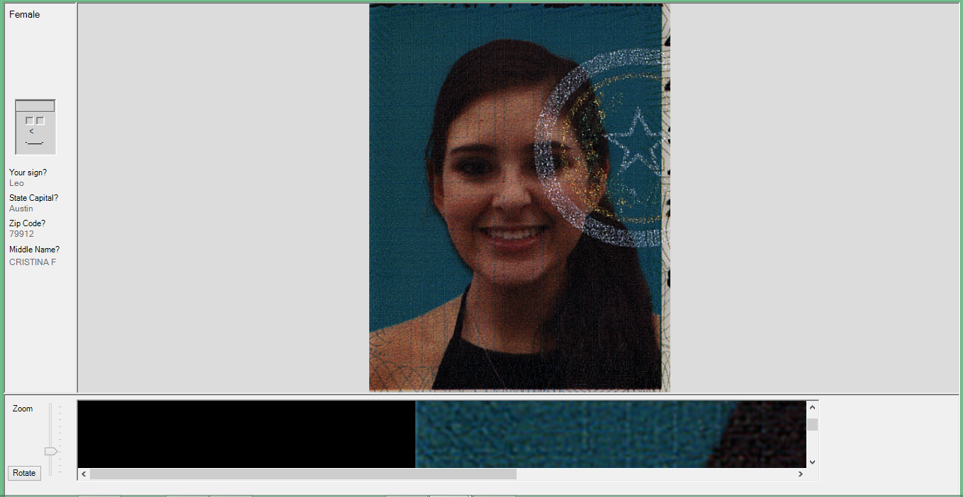

The ID photo is easily blown up to full screen by simply clicking on the photo (in the same manner as the ID image). Another click will bring you back to the Summary screen. When the Photo is blown up to full screen, the display is slightly different as shown below. The right side of the display is devoted to the photo itself, which will scale itself to optimally fill the screen.
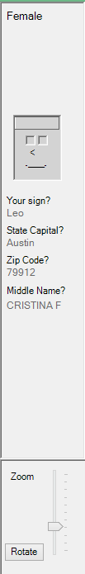
On the left side, there is a special vertical information bar. This information bar has biometric information for the user as well as some helpful questions that could help validate if the presenter is indeed the owner of the ID. The top of the bar will contain Gender, Height, Hair and Eye Color information. The Face icon will reflect the hair and eye color if that is contained on the ID. If the gender is Male, the hair will be as shown and if female the icon hair will be longer on the sides.
The questions are designed to assist you in determining if the person is indeed the person depicted on the ID.
- Sign: If the ID is borrowed from another person, then the presenter may not know their astrological sign.
- State Capital: Many fake IDs are from states other than the residence of the fake presenter. For example, a Massachusetts resident with a fake California may not readily be able to tell you the state capital of California.
- Zip Code: Hesitation in rattling off the zip code might indicate further investigation.
- Middle Name: Imposters may not readily know the middle name of the person from whom they borrowed the ID. One effective trick is to ask the presenter “What does the G in your middle name stand for?” (even if their middle name does not start with G). They will either set you straight or guess (George?).

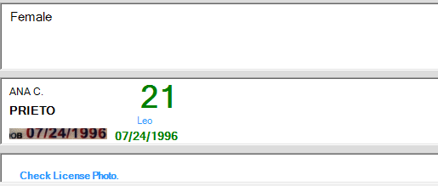
Results Quadrant
The lower right hand quadrant contains information on biometrics of the person, their name, age, and date of birth, the type and series of the ID, and the overall authentication result. In addition, there are some buttons to clear the result and minimize the application to the system tray. A logo and copyright are also displayed.

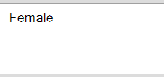
Biometrics Panel Display
The biometrics panel displays information about the physical characteristics of the person that are available from the ID. These include the gender of the person, height, weight, hair color, and eye color. The characteristics that are present on a given ID will vary with the jurisdiction from which the ID originates.

Name / Age Panel Display
The Name/Age Panel provides the name of the person depicted on the ID. The upper line provides the First Name and Middle Initial. The second line provides the Last Name (bolded).
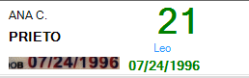
Under the name is the actual image cutout of the Date of Birth on the ID. While this image is small, simply clicking on it will bring up a full screen image of that section of the main license. At this greatly magnified view, it is easier to see if the expiration date may have been manually modified. To the right of the image cutout is the Date of Birth that was read from the ID (derived from the barcode, magnetic stripe, or printed date of birth).
On the right side of the panel, the calculated age in years is provided. The age will be in Green if the ID passes all the checks and Red otherwise. Below the age is the person’s astrological sign in cyan. This can be used as the basis of a quick question to the bearer to help determine if they are the depicted person or whether they have altered the date. The date information is displayed in the MM-DD-YYYY format.

Result Panel
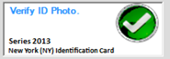
The Result Panel contains the overall result of the
ID examination. A large Red “X” indicates a failed ID, while a Green checkmark indicates that the ID risk was considered tolerable. In smaller print at the bottom of the panel is an indication of the type of ID. The Series is generally the year in which the ID was first being circulated. The line below indicates the specific type of ID that was identified. In some cases, the ID will not be identified and will have an “UNKNOWN” classification. This could be due to it being either a fake ID, a badly scanned ID (due to being bent or taped), or possibly a newly issued ID that has not yet been trained into the ID library.

Clear / Minimize Buttons
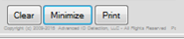
The Clear button will clear the display of images, ID data, and results. The Minimize button will minimize the Verex-ID application to the system tray but will not erase the data.

IDS Logo
The rightmost area in the lower right quadrant will contain the IDScience logo normally. If the Camera option is enabled, the logo will be replaced by a live camera image.

Auto- adjusting Image Size
One notable feature of the ID image display panel is that the size of the display will auto adjust larger of smaller as the size of the overall Verex-ID window is made larger or smaller, always insuring that the ID images are visible.

Full Screen Display
You can easily get a much more detailed display of these images simply by clicking on them, which will immediately expand the picture to full screen. To get back to the primary Verex-ID screen, simply click anywhere on the full-screen image. This makes it very easy to take a look at the detailed image and get back (with just two clicks in the same location). You can see detailed looks at the Near-Infrared image and the Back image in the same manner by simply clicking on these images.

Additional pages provide more information should the operator wish to delve further into the details of the ID. These include a Forms tab (which breaks out the extracted data into individual text data fields), a Tests tab which outlines the individual security test results for that class of ID, a Micro/Pat tab which highlights some special regions of interest for that particular type of ID (usually a microprint or other small detail security feature), and a Cross-Check tab which contains the actual magstripe and barcode content as well as cross comparison of results from OCR, barcode, and magstripe data sources.

Forms Tab

The Forms tab can be used to take a look at detailed forms information.
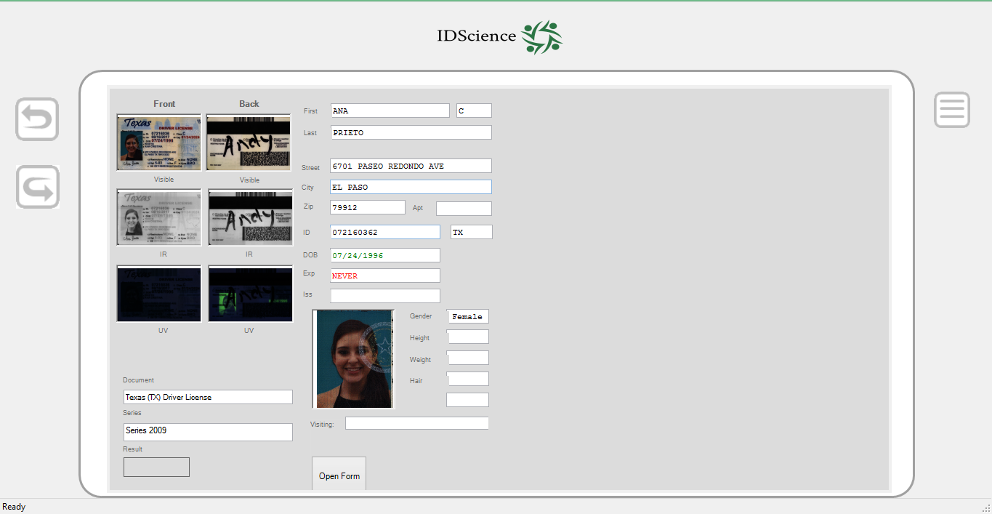
The left side shows all the images that were captured— with the Front images on the left image column and the Back images in the right image column. For the IDS-1000 scanner, there are three images captured: Front and Back Visible image and Front IR image.
Under the images will be information on the document itself– the exact type of document (e.g. Massachusetts (MA) Driver’s License) and its Series (e.g. 2010). The Series is typically the year of first issue for that particular variant of a document.
The right column provides detailed text information extracted from the ID, including name, address, ID number, date of birth, expiration, gender and other available biometric information (e.g. height, weight, hair, and eye color). These are all fields that are able to be edited, and this information can be corrected here (in case the data logging options are enabled).
The “Form Filling” box has an “Open Form” box. Normally this will open a form filling application where the data on this form page can be used to populate an onscreen form. By default, we have “Tag-A-Keg” and Police Booking forms available. The type of form is chosen in the Options/Form section. Note that the form filling application is not installed by default. Please contact Tech Support if you are interested in form filling or custom forms.

Tests Tab

The “Tests” tab outlines the individual security test results for that class of ID in tabular form. The overall consensus on the ID is derived from summing up the results of these individual tests. There are three columns shown: Risk, Test, and Description. For any given type of ID, there is a customized set of security tests that are used.
The Test column provides the category of test that was run, while the Description column describes what the test does.
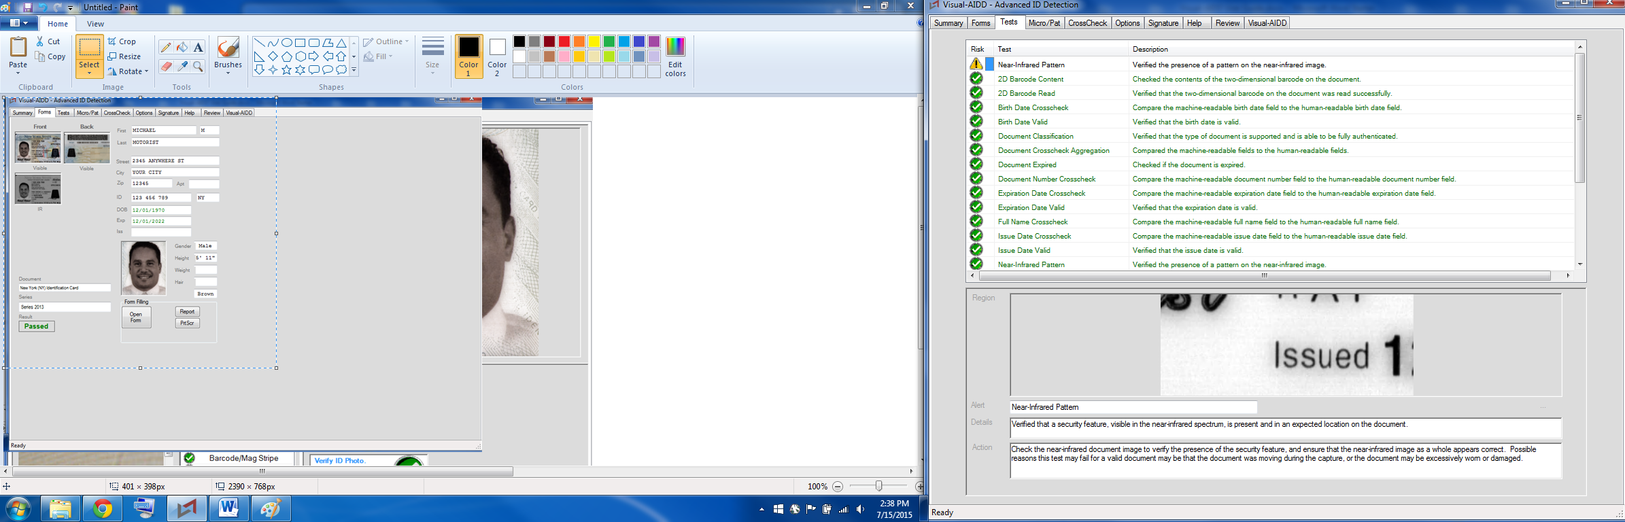

Micro/Pat Tab

The Micro/Pat tab highlights some special regions of interest for that particular type of ID (usually a microprint or other small detail security feature). These areas may be useful for manual validation of an ID. The regions highlighted here will tend to have features that may be more difficult to forge. Not all types of IDs will have regions highlighted. We are constantly adding new regions for inspection.
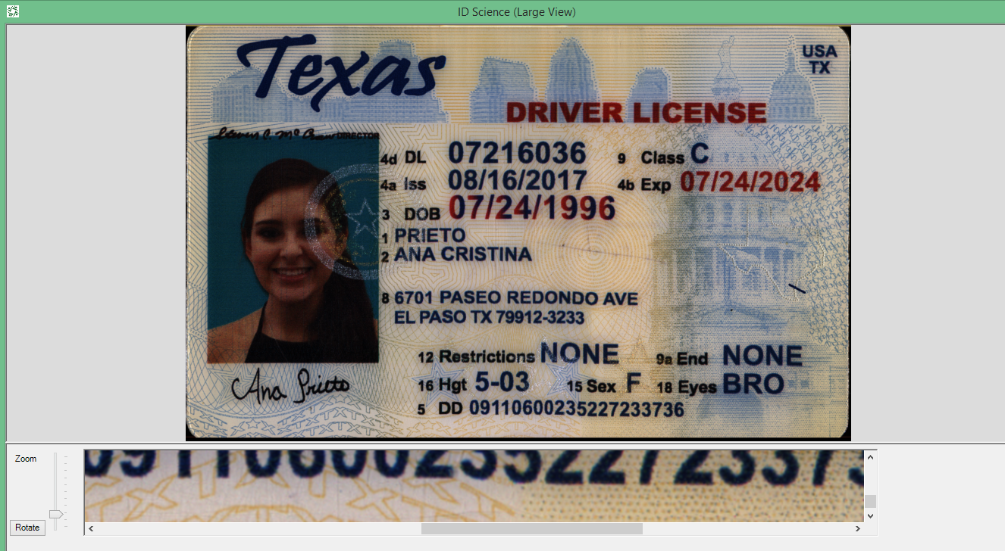

The top area of the screen will contain full images from which the special regions of interest are derived. These may include front and back visible images, as well as IR or UV images. The areas of interest are highlighted in yellow boxes on the images and numbered. Clicking on any of the images will result in a full screen display of that image (including the yellow boxes).
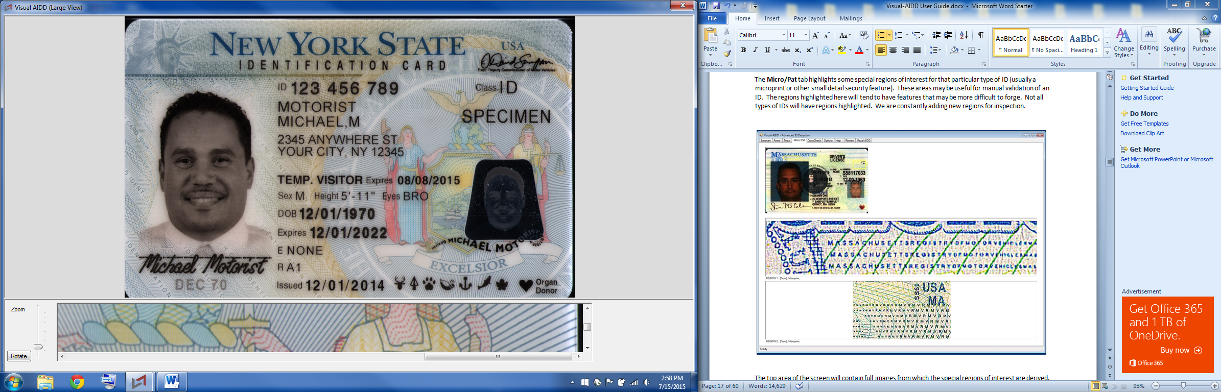

Below the full image area, up to three regions of interest may be shown. Each has a magnified image and a text description. The text description will include a Region number corresponding to the yellow box in the upper images. It will also include a brief description of the type of feature to be seen (e.g.
microprint, pattern, etc.) and may include the actual microprint text and color information (e.g. RMVRMVRMV…). Note that the region of interest images can be clicked and viewed full screen as well.

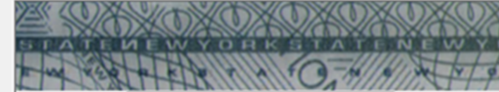

CrossCheck Tab

The Cross-Check tab contains the actual magnetic stripe and barcode content, as well as cross comparison of results from OCR, barcode, and magnetic stripe data sources.

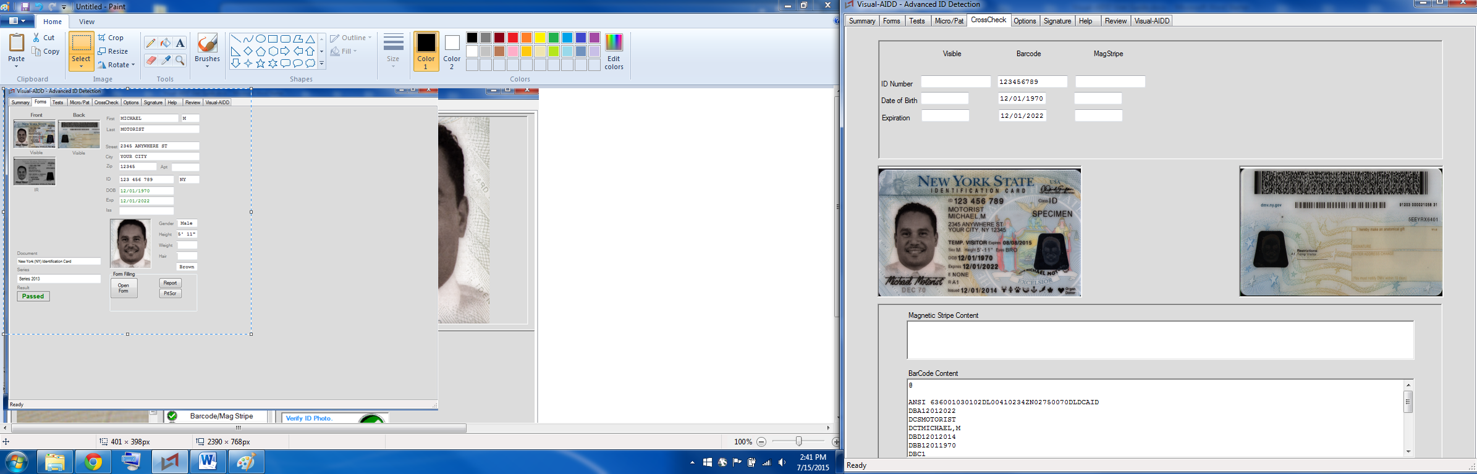

The top area contains three columns labeled “Visible”, “Barcode” and “Magstripe.” Currently there are rows indicating ID Number, Date of Birth, and Expiration. On any given ID, the same data for certain information can be obtained from up to three different sources: by reading the printed information on the front of the ID, by decoding the 2D barcode on the back, or by decoding the magnetic stripe information (if present). A crosscheck of these data against each other is one of the security tests that are used.
The front and back images are displayed in the middle area. Clicking on these images will blow them up to the full screen view where the magnifier function can be used. These images are useful for seeing the original printed material and if there are any factors that might have caused the visible data to be misread. The back view can help verify if there is a readable 2D barcode. Sometimes, the barcode might be so worn as to be unreadable. This may cause a “crosscheck” error resulting in a rejected ID although the ID may just be well worn. Even though a magnetic stripe is displayed, the magnetic stripe derived data may not show up because the ID was scanned upside down such that the magnetic stripe did not travel across the magnetic head in the scanner.
The lower area contains two text areas, “Magnetic Stripe Content”, and “Barcode Content”. If no data was read, these may be blank. Otherwise, they will contain the raw data content from these sources. The barcode data is scrollable so that by using the scroll bars, you may view all of the content.

Camera Tab

The “Camera” tab is shown only if the Camera option is selected from the Camera tab on the Options page. The purpose is to enable one to compare the ID photo with the live snapshots of the presenter.
The left image is the photo derived from the ID. The right side tabs are for snapshots taken by the live video camera during a scan (2 camera captures take place immediately after the document is inserted into the scanner). Below the snapshot tabs is a live video window. Clicking on the live video window will cause the current video frame to be copied into the first snapshot tab.
The camera settings are found in one of the tabs on the Options page. Verex-ID typically uses an external webcam. We recommend the use of Logitech webcams although others can work as well. The webcam should be installed separately according to the manufacturer’s instructions. The zoom, focus, and other settings are typically set in the external manufacturer supplied program. The Camera feature can also be used with the internal laptop camera if it is so equipped. When Verex-ID starts and there is more than one camera available, then a dialog box will appear which will allow one to select which camera to use. Normally, you would choose the external camera.

Help Tab

The “Help” tab has information on the version of the software, where to find assistance, and is the gateway to the help documentation and user guide.
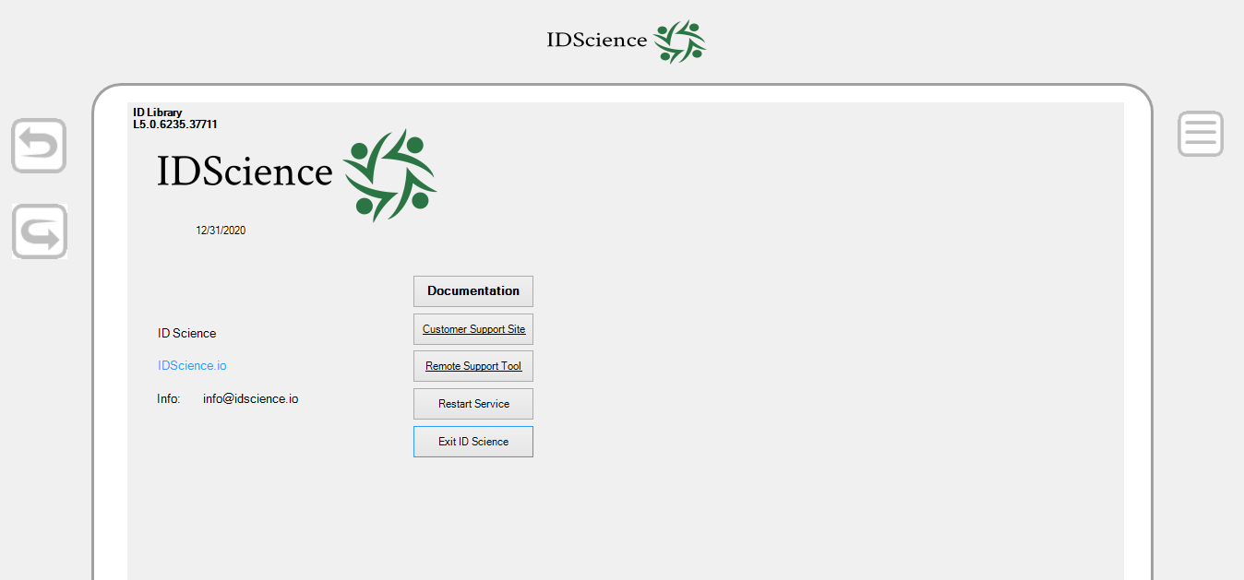
The Help tab contains important information on the version of Verex-ID and ID Engine which is currently installed. In the information area you will find the following:
- Month and Year for this version: This is the month and year in which this version was issued (e.g. October 2012).

- Verex-ID Version Number: Typically the version number will correspond with a year and month of issue. For example, in Version 2.101, the 2 would indicate 2012, 10 would indicate October, and 1 would indicate a revision number.
- ID Engine Version Number: The ID Engine version number is separate from the Verex-ID version number and represents the version of the ID Engine and library that is currently installed. Verex-ID is the user interface portion of the product while the ID Engine represents the current ID library and authentication engine. You may have noticed that updates have two distinct phases – first the Verex-ID update, and then the Verex-ID update. It is important to check the version numbers after an update to make sure that the correct versions have been successfully installed. When you call tech support, they will typically ask you for your current version numbers. An example ID Engine number would be “4.2.2882”. In this example 4 represents the major version number, 2 represents the minor version number, and 2882 represents the “build” number.

- Date Code: There is a date code included in the format “YYYYMMDD”, for example, 20121007, which would represent the date October 7, 2012. This would be the date that this particular version was officially released.

- Device Type: This represents the device type that was used for the last scan. For ID Scanners, this will typically be our IDS-1000 model.

- Serial Number: This will typically be the serial number of the device used for the last scan. This information can be helpful for technical support since there are several revisions of scanners in the field with slightly different characteristics.

- Key: This is the license key for the ID engine. This key can also be found by right clicking the Verex-ID logo in the system tray and selecting “Activate License”.

- Copyright Notice: This is the copyright notice for the Verex-ID product.

- Website and Telephone: You can find our website (www.idscience.io) (508-321-1671), Sales contact information (sales@idscience.io), Technical Support contact information (ids.zendesk.com and 508-388-1818).

- Total Scans: This number will reflect the total number of scans that have been processed since Verex-ID was last installed.

- Scans Since Cleaning: This number reflects the total number of scans since the last time that the
“Scans Since Cleaning” number was reset. This number can be reset to zero by clicking on the “Cleaned” button next to it. The system keeps track of the number of scans and will remind a user when they start up Verex-ID if they have done enough scans to warrant a cleaning. The default setting for scans between cleanings is 200. This number can be set in the Options/General tab.

There are a number of buttons on the Help tab which are described below:
- Cleaned: This button resets the “Scans Since Last Cleaning” count back to zero. Typically you should reset the count after cleaning the scanner.

- Documentation: This button is the gateway to the user documentation and manuals available to help you better use the Verex-ID system. The Documentation is covered in its own section.

- Restart Service: The Verex-ID ID Engine runs as a so called Windows Service. For any scanning or ID processing to occur, the Verex-ID service must be in a “Ready” state. By clicking this button, an attempt will be made to manually restart the service if it is not already running. The status bar will usually display the current state of the service.

- Exit Verex-ID: This button will exit the Verex-ID application. This has the same effect as clicking on the X in the upper right hand corner of the Verex-ID application.

Review Tab

The “Review” tab is an important aid in looking back at past data. This tab is meant for use by managers and for law enforcement use. The Review tab feature is only available if a password is enabled on the Verex-ID system. This feature is set in the “Options/General” section. It also requires that certain features in the “Options/Logging” section be set – the “Samples” checkbox must be checked as well as the “Compressed” checkbox.
If the Review tab is clicked, the following screen will appear with an entry box with the prompt “Type Password <Enter>”. Type the password followed by the Enter or <CR> key.
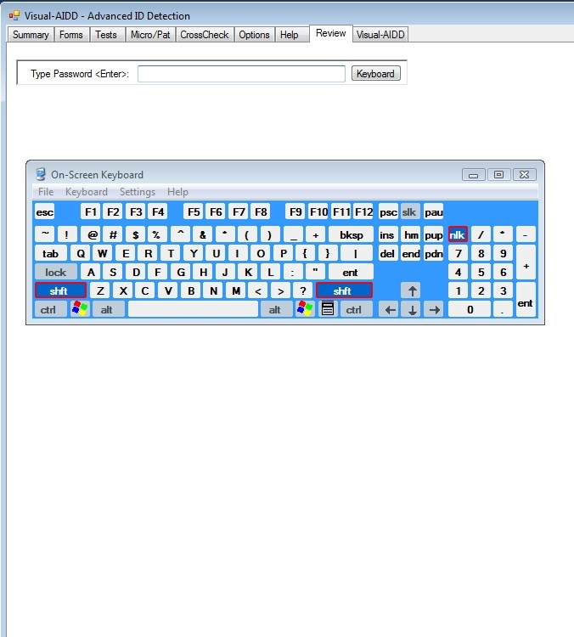

If your system does not have a keyboard conveniently available, then you might be able to use the “On Screen Keyboard” (OSK) functionality of Windows. Pressing the “Keyboard” button should run the OSK.exe program which will enable you to type with a mouse on the screen. First, click into the password entry box and then enter the password and “Enter” via the OSK.

When the password has been successfully entered, the following display should appear. There may be a delay in its appearance as it will be tallying the IDs in its memory.

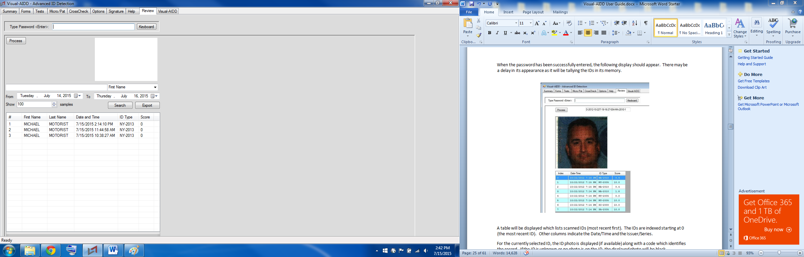

A table will be displayed which lists scanned IDs (most recent first). The IDs are indexed starting at 0 (the most recent ID). Other columns indicate the Date/Time and the Issuer/Series.
For the currently selected ID, the ID photo is displayed (if available) along with a code which identifies the record. If the ID is unknown or no photo is on the ID, the displayed photo will be black.
Clicking on the columns will sort the table according to that particular column. For instance, to quickly find all IDs from Pennsylvania, click on the ID type and scroll down to find all the PA IDs listed in time order.
If you wish to examine a particular ID that is selected, then click the “Process” button. This will decrypt the particular ID and re-process it through Visual-AIDD again as if you had put the ID through the scanner again. The original scanned date and time will be retained. Also, the reprocessed ID will not then generate another entry in the Review table.
When the ID is reprocessed, one could get a quick record of the transaction by clicking <Shift-PrtScr> which will screen grab the image onto the clipboard. Open up Word, Paint, or another program, and Paste the image into it. Then you could print a hard copy from that program.

Privacy

The “Privacy” tab is a logo screen which can be used to cover over results on a temporary basis. If the “Options/Screen” Screen Mode checkbox is enabled, the privacy screen will appear after a specified number of seconds after a scan is completed. Clicking the screen will restore the view back to the main screen (usually the “Summary” tab).

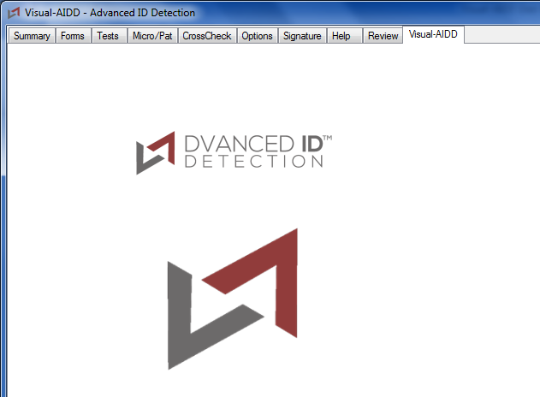

Basic Tab

The “Basic” tab is an optional replacement for the “Summary” tab that contains only basic information. This screen was developed to meet the display requirements for establishments in Utah that use scanners.
The Basic tab can be enabled in the “Options/Screen” tab by setting the “Basic” tab to “Active” and setting the “Primary Tab” to “Basic”.

Options Tab

The “Options” tab allows the manager to configure various aspects of the Verex-ID system. The Options tab can be clicked. If the “Password Enabled” feature is on, then the user will presented with a password entry screen as shown below. Simply type in the password followed by <Enter> and a new set of Options tabs will appear. The Options tab will stay open for a settable amount of time (default is 90 seconds). The Review function is tied to the same password and the Review tab will also be available during that time period. If a keyboard is not handy, then the user could invoke the Keyboard button at the bottom of the “Options” tab to enter the password or other needed data for setting various options. 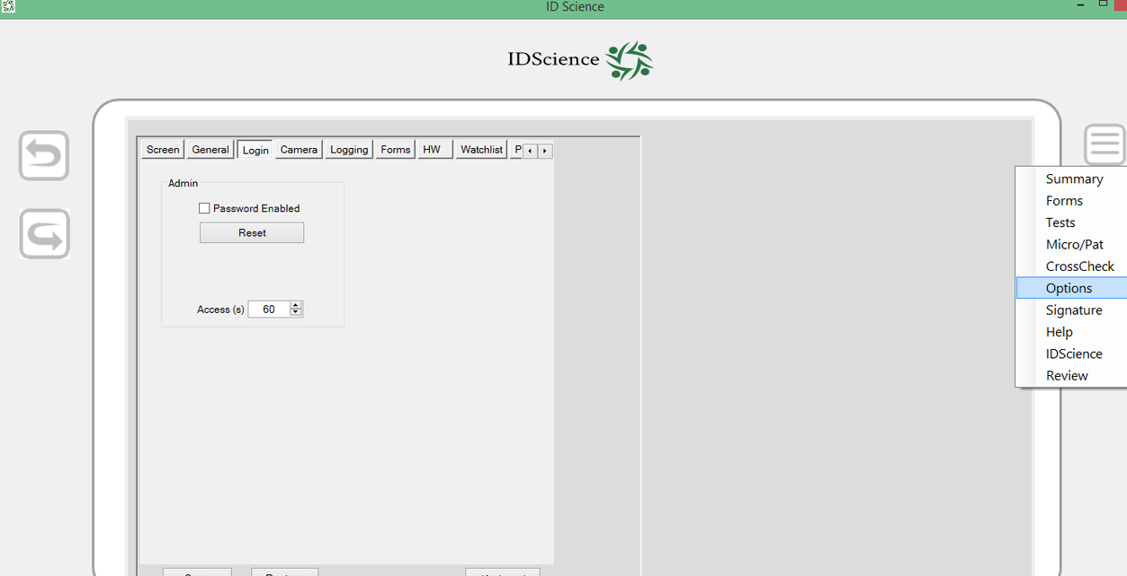

Simply type in the password followed by <Enter> and a new set of Options tabs will appear. The Options tab will stay open for a settable amount of time (default is 90 seconds). The Review function is tied to the same password and the Review tab will also be available during that time period. If a keyboard is not handy, then the user could invoke the Keyboard button at the bottom of the “Options” tab to enter the password or other needed data for setting various options.
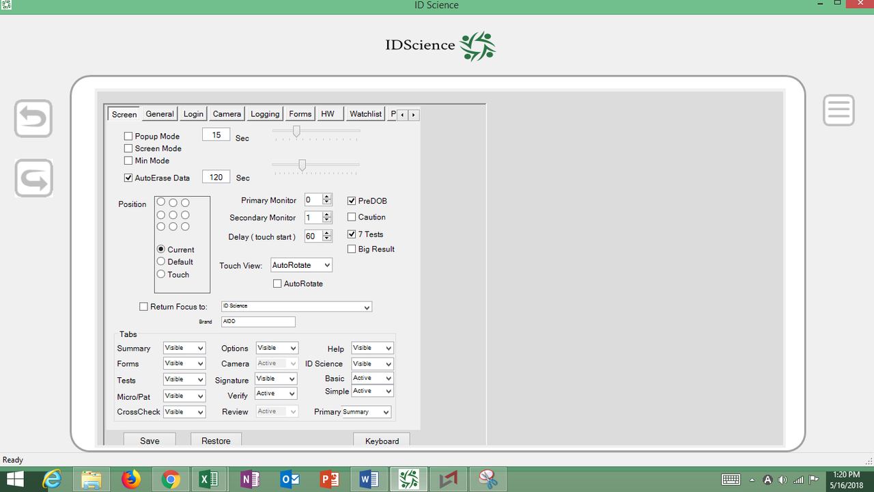

Below is a list of the options tabs and the settings available on each with some explanation.

Options / Screen Tab

Screen – The “Screen” tab allows you to set screen properties. You are able to choose a mode: Popup, Screen, or Min. After a given amount of seconds (which you can set the amount in this tab), something will happen. Popup mode means that the Summary screen will minimize after the allotted time interval. In essence, the information “pops up” for just a short amount of time, providing for the privacy of the person presenting the ID. With Screen mode, the ID information will disappear and the Verex-ID screen will take its place after the allotted time interval (this is especially useful for privacy in that the ID presenter’s information will not remain on the screen for very long). Using Min Mode allows the Verex-ID screen to run in minimized mode, although if necessary you can simply pull it up. It’s important to note that you can access the all of this information in all of these after it goes away as soon as you re-enter the summary screen. Another feature of the Screen tab is that it allows you to select the “Auto-erase” option, meaning that when you remain on the summary screen, the data will disappear after the time you have designated for the Auto Erase option. It can be accessed again by using the “Review” tab. Additionally if you are clicking around from item to item on the summary screen, it will not erase itself before you have completed your examination of the ID via the tools presented. Another feature of the Screen tab is the ability to choose which position the IDScience window will be in on your home screen (if it is not already full-size). The bottom of this tab is where you can choose which of the tabs you want the program to keep visible. You can also choose your primary tab— the tab that will appear upon scanning an ID. The default Primary tab is the Summary tab.

Options / General Tab

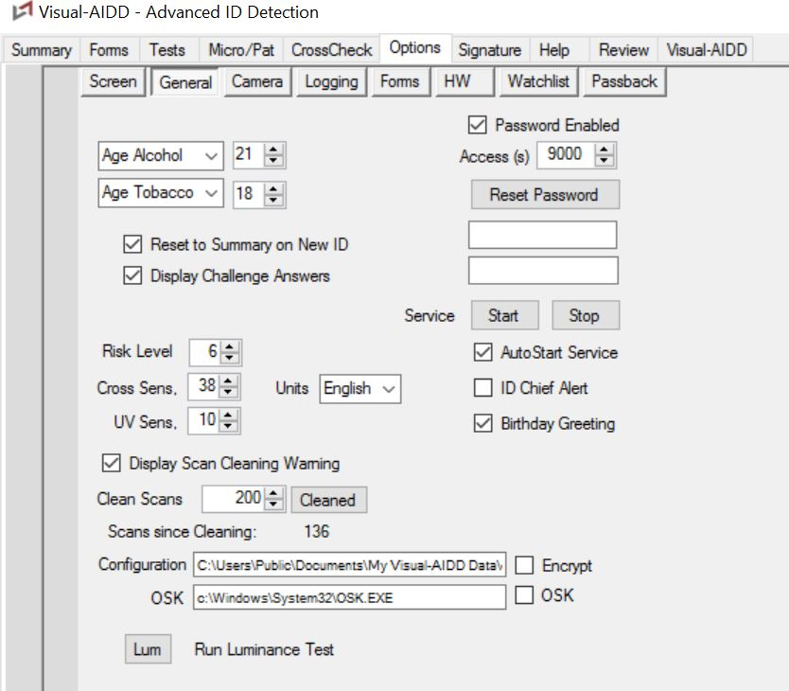
General – The Options tab called “General” houses many important options. Here you can set the legal ages to purchase both alcohol and tobacco in your jurisdiction. You can choose to select options such as “Reset to Summary on New ID” and “Display Challenge Answers”. You have the ability to choose whether the Options will be password enabled, as well as set your password. The option to start and stop the services of the program is located here, as is the choice to enable “AutoStart” Service. You set your Cross-Match Sensitivity and UV Sensitivity here, and can select to enable “ID Chief Alert” which will alert you when someone is using a fake ID made by this maker. Also in the “General” tab is where you decide the amount of scan you can do before you get a cleaning alert, and it is where the program tells you how many scans have been done since the last cleaning. Lastly, this tab offers the options to both encrypt the configuration and enable OSK.

Options / Camera Tab
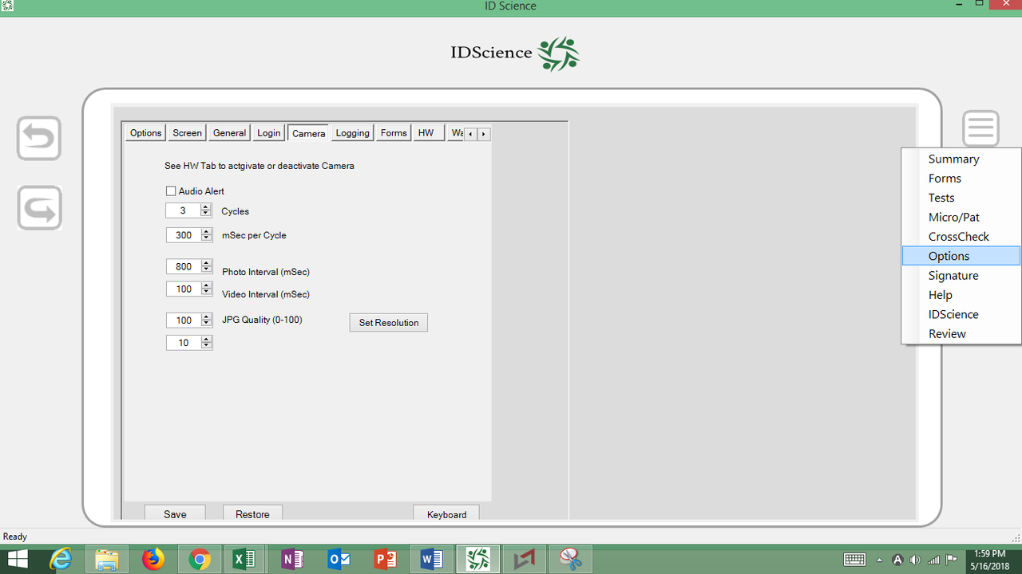

Camera – In the “Camera” tab, you are able to set camera characteristics and settings. You can enable an audio alert upon ID insertion and set both the amount of cycles and the mSecs per cycle. Here you choose the Photo and Video Intervals (both in mSecs), and choose the JPG quality and set resolution. Facial matching is optionally available. Note that you activate or deactivate the Camera under the “HW” tab, NOT the “Camera” tab.

Options / Logging Tab

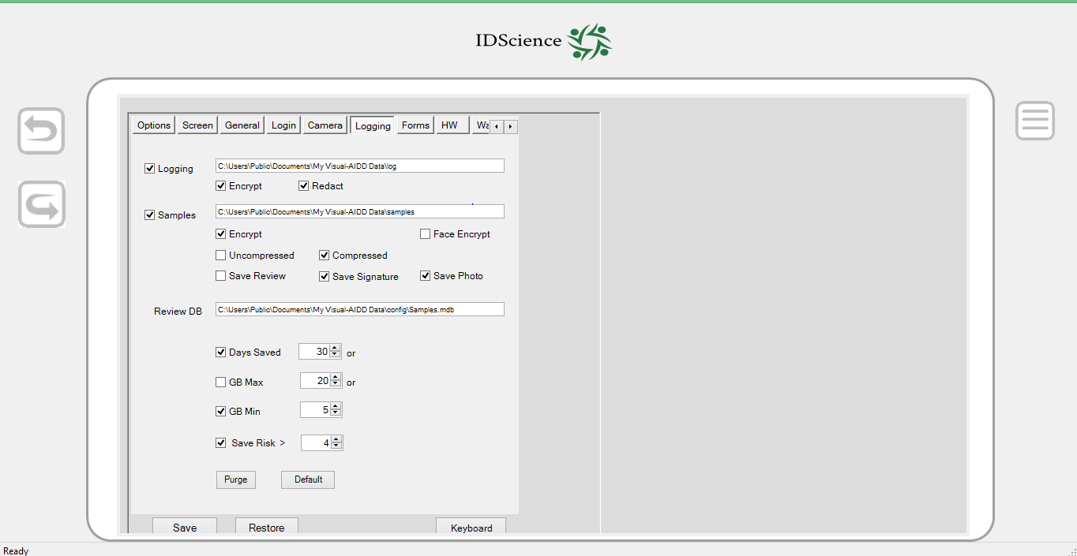
Logging – The “Logging” tab allows for the determination of how logs and samples will be stored. The Log Files can be encrypted or redacted. The sample images can be encrypted, face encrypted, uncompressed or compressed. You can also select to enable the “SaveReview” feature. Under the “Logging” tab is also where you can set the amount of days that data will be stored for, as well as your GB maximum and minimum (if you choose to enable any of these features). Additionally, you can choose to “Purge”, meaning that this “Purge Erase Feature” will secure erase by overwriting.

Options / Forms Tab

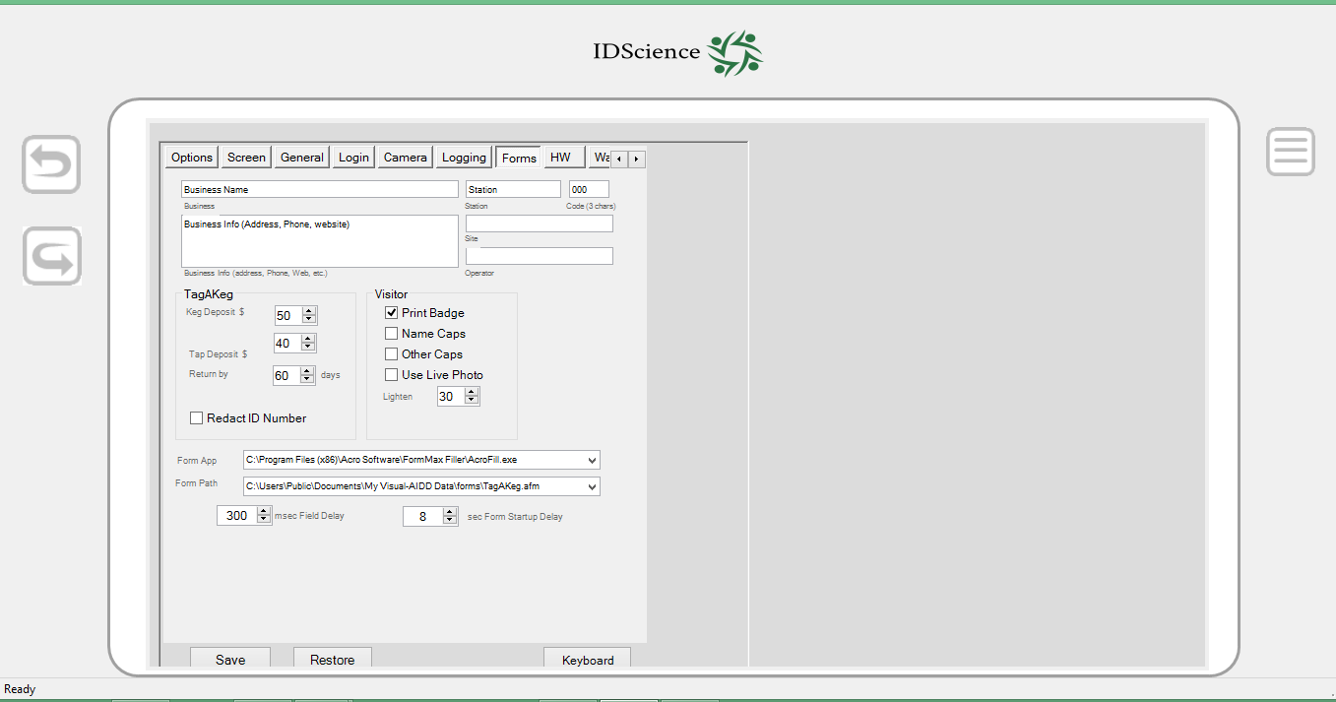
Forms – The “Forms” tab provides options used for Tag-A-Keg and other form filling applications. Here you can insert your establishment’s name and information to be inserted at the top of all of the forms. For “Tag-a-Keg”, you can set a given keg deposit amount, tap deposit amount, and a “Return By” time interval. You can also choose to redact the ID number. For visitors, you can opt to print badges, use Live Photo, use Name caps, or use other caps. You can also pick the degree by which you wish to lighten the live photo. Lastly, on this tab, you can decide the amount of time you desire for Field Delay, as well as the time for Form Startup Delay.

Options / Watchlist Tab

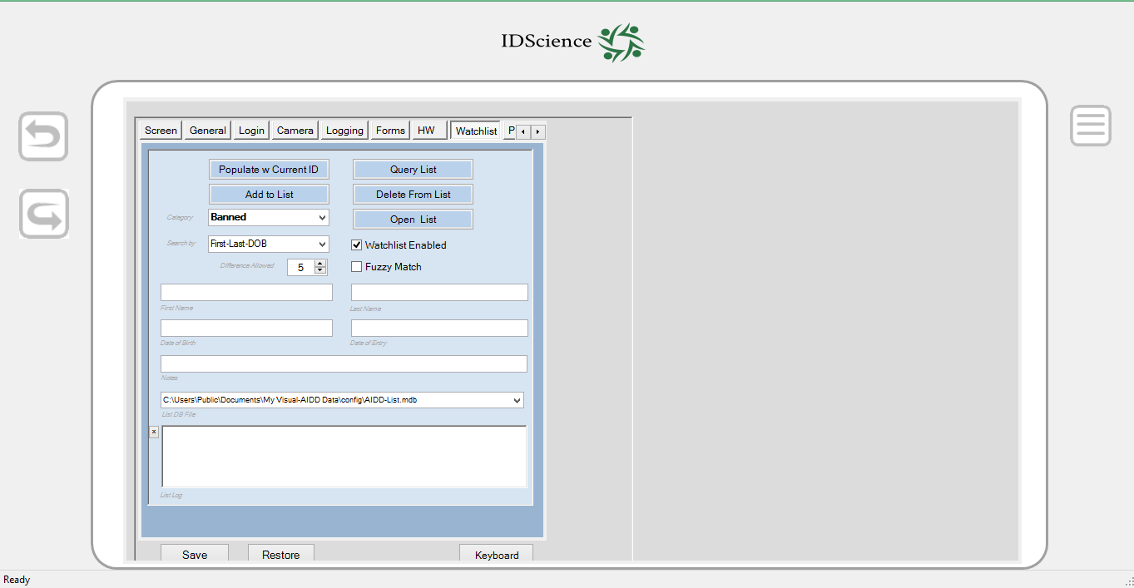Watchlist – You can add an ID to one of the predetermined categories or even specify custom categories. The drop down “Category” menu will allow you to select from a number of possible entries (Banned, VIP, Self-Exclusion, etc.). Make sure that you select the proper category! The “Populate w Current ID” button will fill out some of the information in the tab (First Name, Last Name, and Date of Birth). The “Date of Entry” field will be the current date. The “Notes” field allows you to specify additional information (e.g. “started fight”, “no cover charge”). Pushing the “Add to List” button will immediately store the entry in a database file and a confirming message will appear in the “List Log” area. There are also options to allow a match on “first and last name only” or “last name and date of birth”.

The “List DB File” field specifies where the database file is stored (either locally or perhaps in a networked drive accessible to multiple stations). The file is currently stored as a Microsoft Access database file (with a “.mdb” extension). Its default location is in the Verex-ID “config” folder. However, a major advantage is that the file can be read from and written to from multiple workstations and any local changes made will be immediately available to other stations utilizing the same database file (e.g. multiple entrances at a gaming facility). For more information on this advanced feature or for help configuring multiple systems, please contact tech support at 508-388-1818.

The “Query List” button will query the database for the current information while the “Delete From List” button will remove an entry from the database and will report the results in the log. The “Open List” button will attempt to open the database file with whatever application is currently used to deal with Access database files (typically Microsoft Access if it is installed). One can use Microsoft Access to import large existing lists form other sources (Excel, CSV) into the database used by Verex-ID.

The Watchlist window and menu can be accessed directly from the Summary Tab after an ID is scanned, the WATCHLIST button is located next to the CLEAR and MINIMIZE buttons near the bottom of the Summary screen. This gives the user the ability to quickly add a person to a list without requiring the Review function. If you do not see the button, you need to enable it by marking the corresponding checkbox in the HW tab under Options and clicking “Save” afterwards.
When an ID of a person whose identity matches someone on the watchlist is scanned, a message similar to the following will appear:
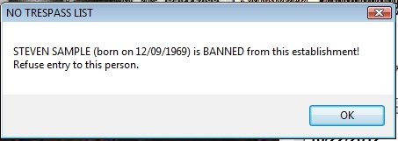

Options / Passback Tab

When enabled, this feature records the name and date of birth of each ID scanned into a temporary database. Thus, one can be alerted when the same ID is presented again within a certain time range. The passback feature and the passback alert range can be set on the Options/Passback tab. This feature guards against patrons passing a genuine ID back to someone else who may look similar (but may be underage) to utilize to gain entrance. It is important to do a facial check against the person!
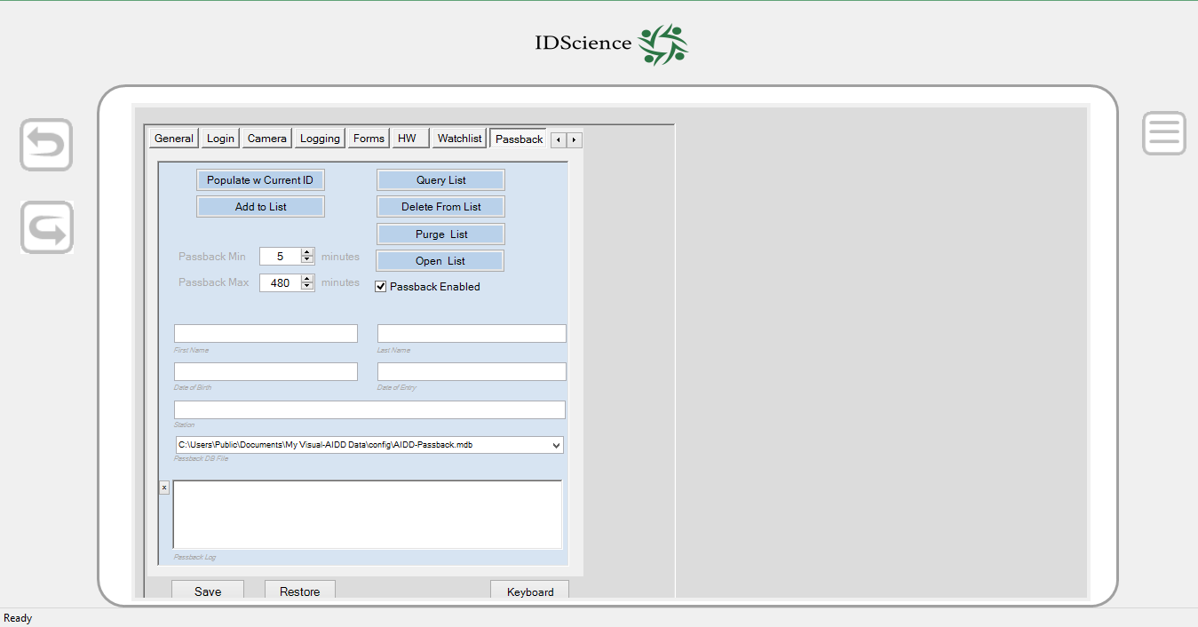

The database file itself can by default reside in the standard local “Config” folder but could also be specified to be on a network accessible drive, and in fact can be the same database file for all stations with access to that common file location. This allows one to detect usage of the same ID at multiple entrances within a specified time frame. The Options/Passback tab allows searching for past occurrences of a particular ID and is also used for setting the Passback options.

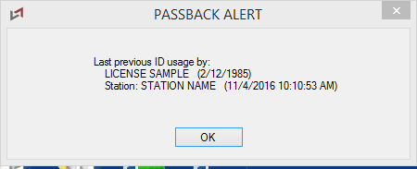
A key factor in this approach is setting the “Station” name for each workstation in a multi-station environment such as a gaming facility with multiple entrances. You already may be familiar with setting the Business Name on the Options/Forms tab. This field identifies the business and is used in generating the Report Form. Two other fields can be filled out on this tab —Station for entering the particular location at a facility (e.g. Front Entrance) and Operator (e.g. employee name/number).

Options / HW Tab

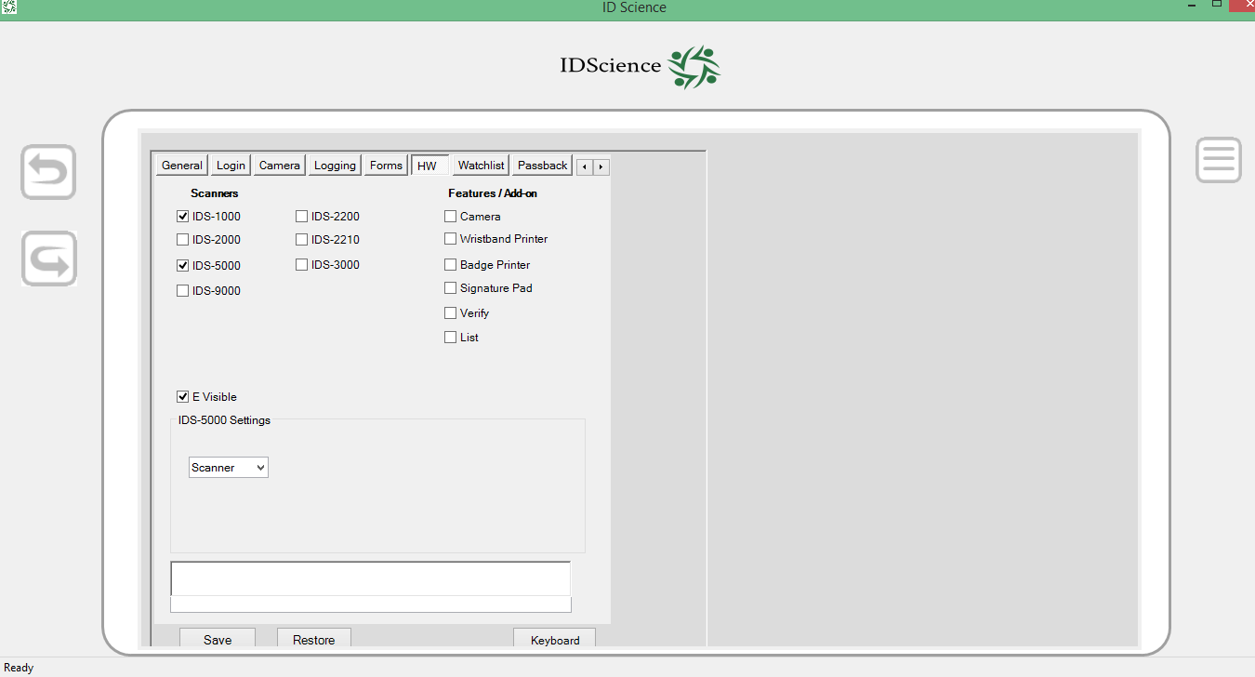

HW – The “HW” tab selects hardware scanner devices which may be used. You choose your reader (IDS-1000, IDS-5000, or IDS-9000). This tab is also where you can opt to enable the Camera, Wristband Printer, Badge Printer, and Signature Pad.

Documentation

The Verex-ID Documentation application allows access to a variety of useful guides and links. The application can be launched by clicking the “Documentation” button on the Help tab. If you are using the Verex-ID installer, then you can launch the application by selecting the Documentation button.

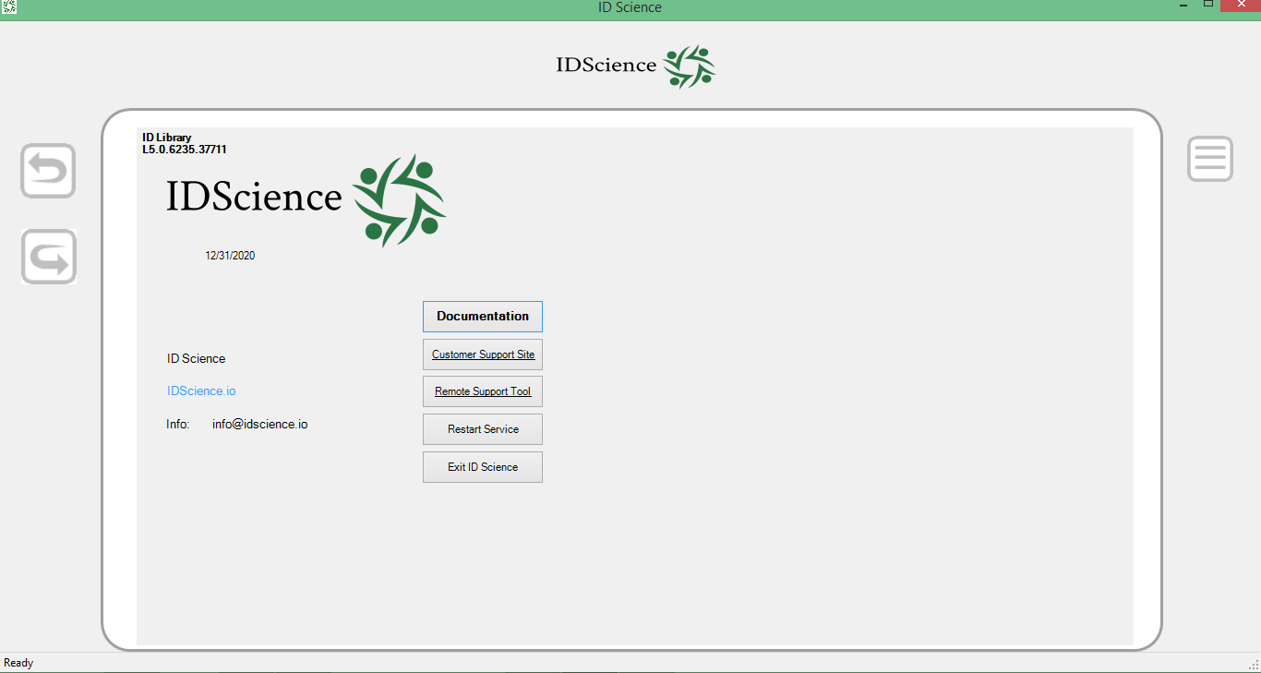

The buttons are set up to display PDF versions of the particular document by automatically launching whatever your default PDF viewer is. The buttons are the following:
- ID Newsletter – This is a monthly newsletter highlighting updates to the Verex-ID system and the ID engine, including any new IDs that are supported. In addition, there will be information on new types of fakes that might be encountered, helpful hints in using your system, upcoming events, customer stories, and other useful information.

- Update Guide – This is a monthly step by step pictorial guide to updating your Verex-ID system. The update procedure is usually very similar month to month. A printed copy of this guide is often included with the mailed monthly update.

- Installation Guide – This is a more detailed guide to a new installation of the Verex-ID software.

- User Guide – This is a PDF version of this user guide.

- Troubleshooting Guide – This is a guide to troubleshooting your Verex-ID system and can help you solve the most common issues with your system.

- Cleaning Guide – This is a detailed pictorial guide to cleaning the IDS-1000 scanner. For optimal performance it is important to clean the scanner on a regular basis.

- Document Library – This is a detailed listing of the types of IDs that are recognizable by the system. The document has an explanatory first page, a listing of all the new and changed document definitions for the month’s update, and then a complete listing of all document types (over 2500 documents).

- ID Chief Field Guide – This is a quick pictorial guide to the fake IDs that were available from ID Chief, a Chinese company which was a major supplier of fake IDs to the college market.

- ID Newsletter Archive – This document contains the collected newsletters from the fall of 2010 up to the current monthly newsletter.

- ID Website – This is a link to the IDScience website at www.idscience.io. An internet connection is required for this function.

The IDS-1000 Reader

The IDS-1000 ID Scanner images both front and back sides of an ID-1 document in full 24 bit color at 600 dpi resolution and is capable of detecting microprint, holographic, and other security features. It also collects a Near-Infrared (NIR) image (8 bit grayscale) of the front of the ID and includes a magnetic stripe reader. The scanner is compact and reliable. The cover to the unit is easily opened for cleaning or to clear any jammed IDs.

Specifications:

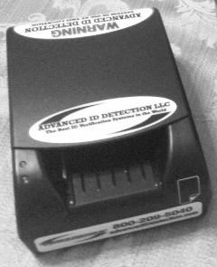
- ID-1 (Driver License size) documents
- Size: W 4.5” x L 6.5” x H 2.625”
- Front ID Insertion with motorized pull-through scanning
- Duplex – image capture of ID front and back
- 24 bit Color Contact Image Sensor (Front & Back)
- 8 bit Grayscale Contact Image Sensor (Front) Near-Infrared
- High Resolution 600 dpi— sufficient for microprint reading
- Magnetic Stripe Head (Back)
- 1D and 2D (PDF-417) bar code reading from image
- Automatic Insertion Sensor
- One Handed Operation
- Easy removal of bent or jammed cards
- Side card guide adjusts to different width cards and insures straight scans
- Maintenance –Alcohol Wipes for mag head and rollers, compressed air
- Auto Orientation Correction
- USB-2 Interface and cable
- Power Adapter – Input: 100- 240V, 50/60 Hz, Output 12v, 1000 mA
- Warranty: 1 year hardware warranty included (extended warranty available)
- Depot service – return to IDScience for repair / replacement

Power

The IDS-1000 is powered with an adapter to convert 110 VAC to 12 V DC. There are a number of different models that have been supplied. Simply plug the adapter into an outlet supplying 110V AC and the pin end into the round receptacle on the right rear of the device. The supply must have a current output of 1000 mA or better for the scanner to work correctly.

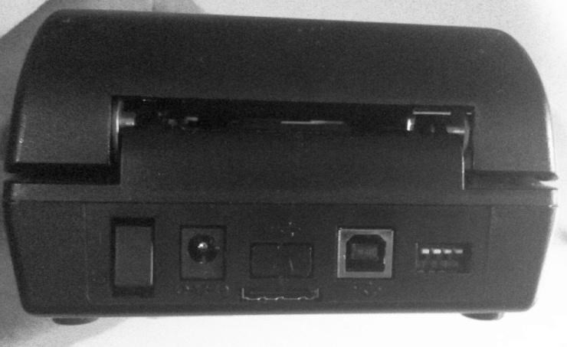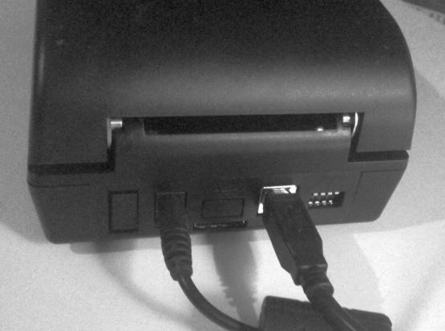

USB Connection

The reader communicates with the computer via USB-2. Please use only the high quality cable supplied with the reader. The square connector is inserted into the USB receptacle at the left rear of the device. The other end of the cable is a standard USB connector which may be plugged into any of the narrow rectangular USB receptacles on the PC or laptop.
Caution: Do not use a USB hub to connect the reader to the PC. On older computers, please make sure that you are using at least a USB-2 connector. Almost all computers from the last 5 years will have USB2 connectors. If by some chance, you are using a USB-1 connector, Windows will typically put up a message. If used on a USB-1 port, scans may work but will be extremely slow. Some newer computers are supplied with USB-3 connectors (usually indicated with a blue connecter). The IDS-1000 is incompatible with some USB-3 ports (notably on ASUS brand computers). On these computers, plug the IDS-1000 into one of the USB-2 ports.
The first time that a powered reader is plugged into a PC, you will receive a notice about a new device being inserted. On Vista or Win7 systems, this process should be automatic. On XP systems, you may have to go through some steps to indicate the proper driver to use.

Power Switch
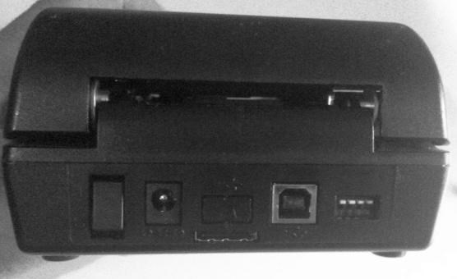

A power switch is provided on the IDS-1000 at the right rear. Pressing the upper rocker of the switch turns the reader ON while pressing the lower portion turns it OFF. The unit may be powered off and on while the Verex-ID system is in use (e.g. for maintenance purposes, to swap readers, or to do a manual reset on the reader).

Indicator Lights

There are two indicator lights on the left front of the IDS-1000. If the reader is powered but not operational or connected via a USB cable, then the lights will be flashing. If both lights are solid, it indicates that the reader is connected via USB and is communicating with the ID recognition software. Note that in cleaning mode, the lights will not be lit (on IDS-1000 readers with double CIS sensors on top) and will have two solid green lights (on IDS-1000 readers with a single CIS combo visible/IR sensor on top).

Placement of the Reader

Sufficient clearance room (2 inches recommended) must be provided at the rear of the IDS-1000 to allow for the ID card to pass out of the back of the reader and back in. If the card hits an obstacle in the back, you will NOT get complete scans of the ID.
Likewise, please make sure that the USB and power cables are placed such that they do not interfere with the travel path of the ID card coming out the back of the reader (as shown below).
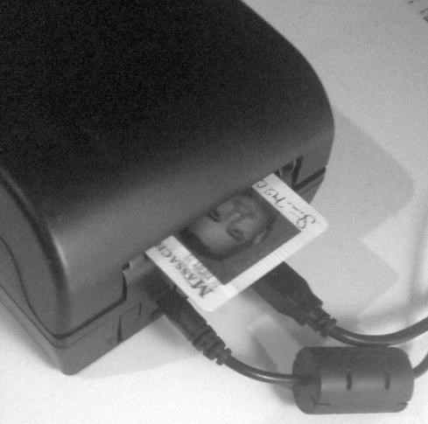

Front Graphics
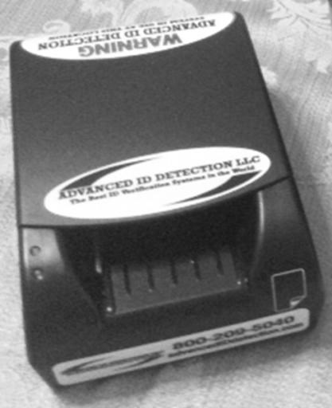
Your IDS-1000 reader is equipped with warning decals on the top. These may help serve as a deterrent to those tempted to use a fake ID. On the lower front of the ID is an IDScience decal with a phone number – 508-388-1818. In case of difficulties, you may call this number for either Technical Support (x2) or Sales Support (x1).

On the right front of the reader is an illustration to help you to insert ID cards in the proper manner. IDs are inserted with the front of the ID facing up and the back of the ID facing down. For most IDs that have a magnetic stripe, the stripe is on the top back side of the license. In some states (e.g. Florida), the magnetic stripe is on the bottom of the back side of the license. The decal indicates that the ID should be inserted with the magnetic stripe face down and the stripe on the right side of the reader (if the ID contains a magnetic stripe).
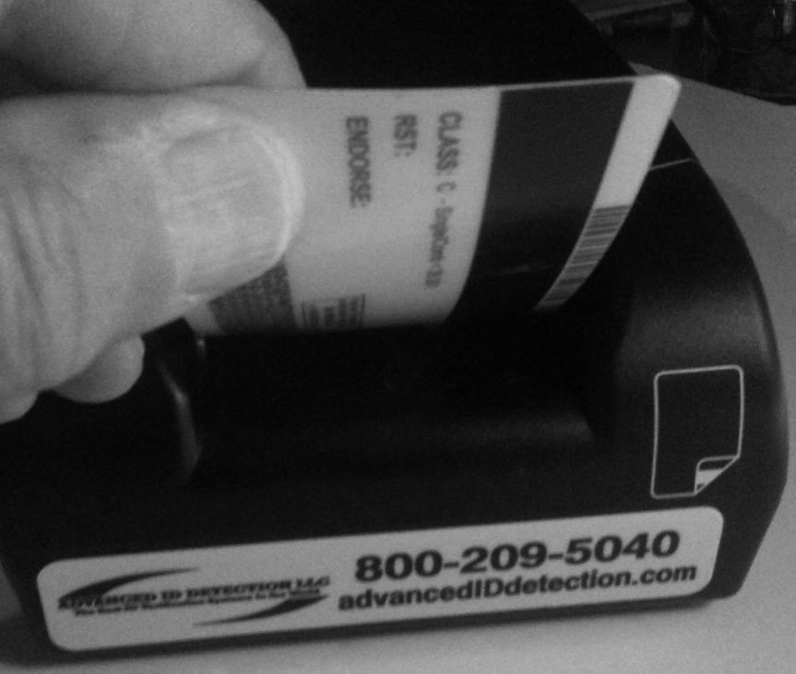
In general, there has been a trend to eliminate the magnetic stripe from drivers’ licenses in favor of the 2D barcode. However, there are still a substantial number of state IDs with magnetic stripes. Most magnetic stripes are on the top back of the ID. One major exception is Florida where the magnetic stripe is on the bottom of the rear ID.
For most landscape format IDs, the ID will be inserted face up such that the bottom of the license will be to the left. For most vertical format IDs (e.g. Under 21), the ID will be inserted face up such that the top of the license is inserted first into the reader.
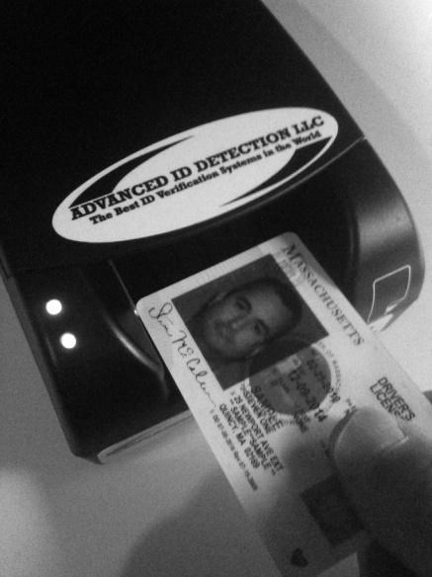

Top Cover

The top cover of the IDS-1000 can be opened up to expose the card path. You may wish to do this for maintenance purposes or to clear a jammed card. Merely lift up on the front lip of the reader to open the cover. To close the cover, press down of the cover until the cover snaps into place.

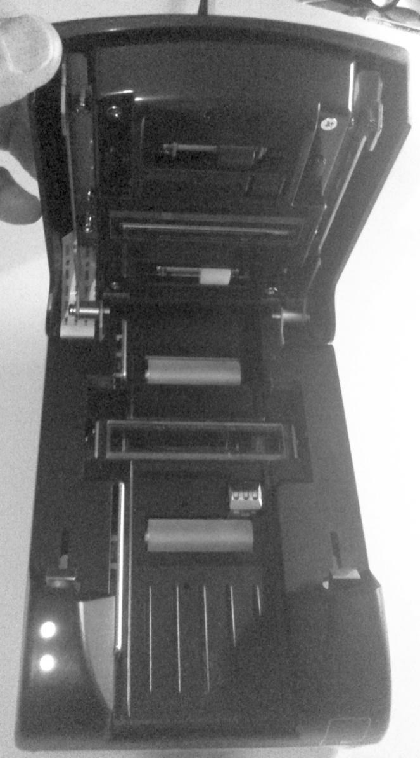

Lower Reader

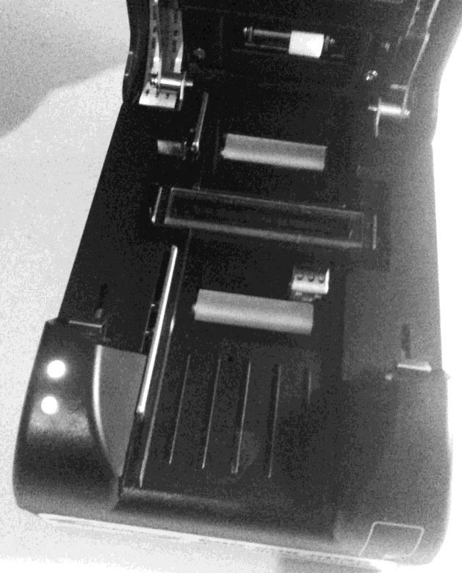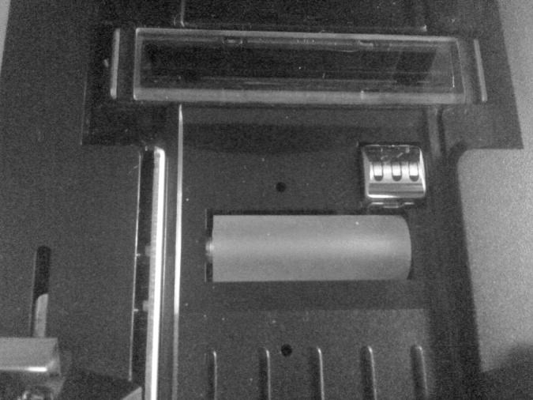

Lower Optical insertion Sensors
These two small holes (and corresponding holes on the top section) form an optical sensor pair to detect when an ID has been inserted into the reader. It is important that these holes not become blocked with dirt. An occasional use of an air duster will keep these clean.

Magnetic Head
The silver magnetic stripe reader head in on the right side of the lower reader is used to read magnetic stripes on those IDs that contain them.

Lower Contact Image Sensor (CIS)
The CIS is the actual image scanning device which has an integrated white light source for imaging the back side of the ID. The lower CIS can accumulate deposits from dirty IDS as they pass through and can be easily cleaned with an alcohol pad.

Front and Rear Rollers
The rubberized front and rear rollers are integral to the operation of the IDS-1000 and serve to transport the ID into and out of the reader via friction. Since these rollers are in direct contact with the ID, they are most susceptible to picking up dirt, oil, and other deposits that may be present on IDs. It is very important to clean these rollers periodically. Otherwise they could become slippery and will not reliably transport the ID through the reader, resulting in faulty scans. You may receive a warning when using Verex-ID that the device needs cleaning.

Left Side Fence
The spring loaded silver fence on the left side of the transport path serves an important purpose of allowing IDs of different widths to be read reliably. While IDs are nominally all supposed to be a uniform size, there are indeed variations between ID types. The fence serves to exert pressure to insure that the ID goes through the transport without skew.

Upper Reader

Upper Contact Image Sensor (CIS) - White
The Upper White light CIS is the actual image scanning device which has an integrated white light source for imaging the front side of the ID. The upper sensors can accumulate deposits from dirty IDS as they pass through and can be easily cleaned with an alcohol pad.

Upper Contact Image Sensor (CIS) – Near-Infrared (NIR)
The upper Near-Infrared (NIR) CIS is the actual image scanning device which has an integrated Near-Infrared light source for imaging the front side of the ID. The NIR sensor provides an important means of detection fake IDs. In Verex-ID, the NIR image is presented. The NIR image will pick up any places where the ink on the ID is carbon based.
Note: there are two versions of the IDS-1000 reader. The latter versions have a single Upper Contact Image Sensor (CIS) which has both White (visible) and Near-Infrared (NIR) sensors in one module.
You may be familiar with the use if UV lights to check for patterns on IDs (e.g. at the airport). Many IDs incorporate IR security features; the presence or absence of NIR printing can be used as an aid to determine if an ID is real or fake. For example, a typical ink jet printer will not use carbon based ink and the resultant NIR based image will not match the real ID.

Rollers
The upper rollers serve to hold the ID firmly against the CISs as the card travels though. The upper rollers are hard plastic but may still be subject to dirt accumulation and should be cleaned.

Lower Optical insertion Sensors
These two small holes (and corresponding holes on the bottom section) form an optical sensor pair to detect when an ID has been inserted into the reader. It is important that these holes not become blocked with dirt. Occasional use of an air duster will keep these clean.

Troubleshooting Guide

This guide will help you solve most of the problems that you may be having using the Verex-ID System. It is organized by the general issue. Suggestions for solutions are provided. If you are still having difficulty, then please contact our technical support number (508-388-1818).
Note: The most common issue reported is that the scanner does not seem to draw cards in. The simple solution to this problem is to reboot the computer.

When you set options in Verex-ID, they are not retained properly.
The Options settings are stored in a special configuration file which is stored in the directory “c:\ProgramData\IDS\config”. Under some conditions, the configuration file can be corrupted or it cannot be properly written to its storage location. Here are several steps that could remedy this solution.
- Set the User Access Control (UAC) level to a lower setting.

Click the Start button, then Control Panel. Select “User Accounts and Family Settings”. Click the “User Accounts” heading. Select the setting to “Turn User Account Control on or off” or some similar wording. You may have only a single checkbox labeled “Use User Account Control (UAC) to help protect your computer” or more likely, a choice of four settings aligned vertically on the left. If the settings are set to either of the top two settings, Verex-ID may not be able to store files correctly. If there are four settings, the recommended setting would be the second lowest setting. Reboot the system for the changed UAC level to take effect.

- Change the IDScience directory to not be “Read Only”.

Sometimes, it may be necessary to change the read/write settings of the IDScience directories to allow files to be written to them. For this use Windows Explorer. Right Click the Start button and select “Explore”. Navigate to the “c:\ProgramData\IDS” directory. It is most likely not visible on the tree view. However you can easily navigate to it via the upper text box in the Windows Explorer screen. Click into the text box and then type” c:\ProgramData”. Right click on the IDScience directory and select “Properties”. If the “Read-only” checkbox is filled, then click it. Next click the “Apply” button. On the window that comes up next, click OK “to apply changes to this folder, subfolders and files.” You can then close Explorer.

- Don’t save the Options Configuration as an Encrypted File

If you are having difficulty with Options settings, there may be a problem with the encrypted version of the configuration file. Check the Options tab in Verex-ID and then the General Tab under that. If “Encrypt Config File” is checked, uncheck it.

- Reset the Options to Default Settings

You can reset the options to default settings by deleting the configuration file and then restarting Verex-ID. A new configuration file with default setting will be automatically generated.

First close Verex-ID. Then, using Windows Explorer, navigate to
“c:\ProgramData\IDS\config”. Right click the file “Verex-IDS.cfg” or “Verex-IDS.cfg.aid”
and select Delete. An alternate method of deleting the config file is to use Explorer and navigate to “c:\Program Files\Verex-ID”. Locate the batch file “resetids” and double click it. This will delete the configuration file. When you restart Verex-ID, a new configuration file will be generated automatically. Note that this will reset the number of scans to zero. The default setting is the compact screen. If you prefer to Verex-ID at full screen size, simply press the “maximize” icon in the upper right of the screen and Verex-ID will expand to the full screen. Then close and reopen Verex-ID. Upon closure it will save its new, full-size position.

Part of the Verex-ID Screen is cut off.
You may find that parts of the Verex-ID screen are not visible when displayed full screen. This is usually due to the fact that a Windows setting was changed to “Make it easier to read what’s on your screen.” A user may have changed the setting from the 100% default setting (“Smaller”) to “Medium” at 125% or perhaps “Larger” at 150% magnification of text, icons, etc. You can read about this setting at To restore the full view, put the setting back to 100%.

Displayed ID Images are smeared.
Displayed ID Image has a consistent line through it.
Seemingly good IDs are consistently rejected.
You may be consistently getting negative results with seemingly good IDs. The images displayed on the screen may be partially or completely smeared. Or perhaps, you see a line going through the ID image on every ID (and there is no corresponding line on the ID itself).
If this happens often, it usually indicates the need for cleaning the scanner. Smeared images typically indicate that the rollers are dirty and ID is slipping a bit on the way through the scanner. Consistent lines through the image indicate that there may be some dirt on one of the Contact Image Sensors (CIS). The easy solution is to follow the cleaning procedure outlined in the “Cleaning Guide” supplied separately.

IR image is all black.
You may be consistently getting negative results with seemingly good IDs. For instance you may have an all-black IR image. This means that IR sensor on top may not be working properly and the scanner may need servicing. It may be that there is a loose internal connector. Tap the unit gently to see if the connection might be restored.

Images are not fully displayed.
You may be getting bad results on good IDs. Check to see that the images are being fully scanned. Is the entire ID shown in the window or are there large black areas on the side of the ID. If so there may be a mechanical blockage at the back of the IDS-1000 scanner. Make sure the back of the scanner is clear of obstructions. Make sure the rollers are clean. Make sure the light sensor holes on the top and bottom are not obstructed with dirt. Spraying with compressed air could clear out these holes or any dust buildup under the rollers. If the front roller is lower on one side than the other, it should be sent for repair.

Images have a large RED “X” through them.
Close the Verex-ID application by clicking the “X” in the upper right corner. Restart Verex-ID by double clicking the Verex-ID icon on the Windows main screen.

ID Validation takes a long time.
The ID validation process typically takes under 7 seconds. On newer machines with fast processors (e.g. i7), processing time may be under 2 seconds. If your system seems slower than usual, there are a few possible causes. Check your power plan settings. For most operation, the setting should be “High Performance”. If it is not “High Performance”, change it via the power icon in the system tray. Another cause for slowdown could be other running processes on your machine. For instance, if your wireless is enabled, the computer could be using the wireless port to do some automatic updates or downloads which can considerable slow the ID response time. Turn off the wireless capability when scanning by either a switch (on most laptops) or by disabling the wireless port in Device Manager.

After an Update, system fails to work
- Reinstall the Update

If the UAC is set too high, sometimes the update may fail. Reduce the UAC level, reboot, and try the update again. In some cases it may be necessary to uninstall the current version and perform a new install.

- Perform a New Install

- In some cases, where there was a problem doing an update, if a retry at doing the update does not solve the problem, it may be necessary to uninstall the current version of Verex-ID and perform a reinstall. This is not too difficult a task.
- Turn off the IDS-1000 reader if it is on via its power switch.
- Close Verex-ID if it is running.
- Shut down the Verex-ID Windows service if it is running. You can tell by looking for the Verex-ID icon in the lower right hand status line. If there is not a red X through it, then right click it and select “Shutdown service”.
- Left click the Start menu and select Control Panel. Under Programs, select “Uninstall a Program”. This will bring up a list of installed programs in a list (which may take a minute or two to completely populate). Find “Verex-ID” in the list and make a selection to uninstall it. This may take a few minutes to complete. When complete, “Verex-ID” will disappear from the list.
- Locate your monthly update/install disk and insert it into your CD drive. From the main menu, select the “New Install” option. See the Verex-ID Installation Manual for more complete instructions.

Stopping and Starting the Verex-ID Service

Verex-ID is the recognition engine behind the Verex-ID system. It runs as a Windows service in the background and is evidenced by a round icon in the Windows system tray in the lower right hand corner of the screen. When the service is running, the tray icon appears as below:

One can halt the service by right-clicking on the icon and selecting the “Shutdown service” option.
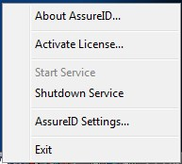
Verex-ID Settings
About Verex-ID

When the service is not running, the round icon will appear covered with a red “X” as shown below.

The service can be restarted by right-clicking on the Verex-ID tray icon and selecting “Start Service”.

Note that when the service is running the two lights on the IDS-1000 scanner are both solidly illuminated. When the service is not running or the device is not connected to the USB port, the two lights will be illuminated but flashing.
If neither “Start Service” or “Shutdown Service” is shown as an active option, you may try to use the
Windows “Services” utility to start or stop the service. Click the Start button and enter the word.
“Services” in the text box. This should find a program called simply “Services”. Find the service called “Verex-ID” in the list and you can control it (start, stop) it from there. By clicking “Properties” you can also control whether it starts up automatically when the PC boots up.

